

**Capstone Project Phase B**

**NODUS - Childhood ADHD Symptom Detection with Possible Solutions**

**(24-1-D-6)**

Mentor: Dr. Natali Levi

Safwan Halabi – 213784127

Bishara Bisharat – 208261990

safwanhalabi60@gmail.com

bish.150b@gmail.com

**Table of Contents**

**Abstract 3**

**1. Introduction 3**

1.1 Problem 3

1.2 Available Solutions 4

1.3 Our Plan 4

1.4 Beneficiaries 4

**2. Background 4**

2.1 Symptom Detection 4

2.1.1 Behavior: 5

2.1.2 Environment: 5

2.1.3 Vocal Characteristics: 5

2.1.4 Eye Movement/Eye-Tracking: 5

2.2 Treatment 6

2.2.1 Medication 6

2.2.2 Behavior therapy 6

2.3 Risks 6

2.3.1 Risks of symptom detection 6

2.3.2 Risks of symptom development 7

**3. Deep Learning Model 7**

3.1 Architecture 7

3.2 Application 8

**4. Technologies 8**

4.1 Django 8

4.2 CV2 / OpenCV 9

4.3 Librosa 9

4.4 Parselmouth 9

4.5 Soundfile 10

4.6 TensorFlow 10

**5. Tasks 10**

5.1 Eye-Tracking and Reaction Task 10

5.2 Vocal Analysis Task 11

5.3 Questionnaire Task 11

**6. Data Availability 12**

**7. Pre-Processing Logic 12**

7.1 Eye-Tracking Data 12

7.2 Vocal Recording Data 13

7.3 Reaction Time Data 14

**8. System Architecture 15**

8.1 System Package Diagram 15

8.2 System Activity Diagrams 16

8.3 System Interface 20

**9. Challenges and Obstacles 26**

9.1 Data Availability 27

9.2 Working with a Virtual Environment 27

9.3 Deployment 28

9.4 Integration of Multiple Components 28

9.5 Obstacles in Design 29

**10. Experiment and Evaluation 30**

10.1 Experiment 30

10.2 Verification and Evaluation 31

10.2.1 Functional Testing 31

10.2.2 Acceptance Testing 32

10.2.3 Summary of Key Acceptance Test Results: 32

10.3 Results 33

**References 35**

**User Guide 37**

**Maintenance Guide 54**

# **Abstract**

Motivated by the increasing number of undiagnosed Attention Deficit Hyperactivity Disorder (ADHD) cases, often linked to expensive traditional testing, this project presents a web application to aid in ADHD detection in children. This application employs a multi-modal approach, utilizing novel techniques like vocal and eye-tracking assessments alongside standardized caretaker questionnaires to gather comprehensive data. On the back end, a trained Artificial Intelligence model analyzes this data stored in a MongoDB instance. This model, trained on historical data from previously diagnosed children, predicts the likelihood and severity of potential ADHD symptoms in the tested child. This web application offers a potentially objective and convenient method for initial ADHD screening. By combining these novel assessments with caregiver reports, it aims to provide a more comprehensive picture of possible ADHD compared to traditional methods. Future work will involve validating the AI model's accuracy through clinical trials and potentially expanding the functionalities of the web application to further enhance its effectiveness. It's important to note that this application does not diagnose ADHD, but rather helps with detecting possible symptoms, allowing individuals to seek further professional evaluation.

# **1. Introduction**

## **1.1 Problem**

ADHD (Attention Deficit Hyperactivity Disorder) and its less hyperactive counterpart ADD (Attention Deficit Disorder) are some of the most common neurobehavioral disorders, particularly prevalent among children. According to Golden Steps ABA, approximately 5.3% of children worldwide suffer from ADHD. These disorders can be extremely disruptive as children grow up, potentially leading to devastating consequences if left undiagnosed. Unfortunately, many cases go unnoticed until later stages in the patient’s life.

ADHD is characterized by three distinct categories of symptoms: Inattention, Hyperactivity, and Impulsivity. Although these categories are directly linked to ADHD, clinicians and researchers still struggle to pinpoint the root cause of the disorder. The specific tendencies and the severity of each symptom vary from patient to patient, but they all fall under the same umbrella. Common traits among ADHD patients include forgetfulness, acting before thinking, getting easily distracted, and difficulty paying attention to details.

What is reassuring about this problem is that early identification allows for effective treatment. The British National Health Service states, "With appropriate intervention, children with ADHD can lead normal lives.

## **1.2 Available Solutions**

Several methods exist today for identifying early signs of ADHD in children, most of which are administered by licensed professionals. One common approach involves a medical examination where a medical professional conducts a series of check-ups that may lead to a diagnosis. Another approach involves a third-party observer, typically a teacher, who monitors the child’s behavior over an extended period to identify potential ADHD symptoms. Additionally, questionnaires like the Conners Rating Scale are used, which ask about general behavior, schoolwork, and social life, providing insights into how ADHD symptoms affect different aspects of the child’s life, such as grades, home, and relationships.

## **1.3 Our Plan**

We developed a mathematically based AI model that took in various parameters and metrics provided by the user regarding their child’s behavior. The model then predicted whether the child potentially had ADHD based on the severity of their symptoms and suggested various solutions and daily habits to help manage the condition.

Our aim was to provide an easy and accessible way for families worldwide to receive an early warning that could save their child from a problem that can significantly impact their life.

## **1.4 Beneficiaries**

The primary beneficiaries of our system were children with undiagnosed ADHD, as well as their families. Our model informed these families about the possibility of their child having ADHD and the severity of the symptoms, while also proposing various solutions and recommending further testing.

# **2. Background**

## **2.1 Symptom Detection**

Throughout the years doctors and medical professionals have developed several methodologies to detect possible ADHD symptoms, many of which were questionnaires and simple tests conducted by therapists to both the patients and their parents [18]. It’s highly recommended for parents to be educated about the disorder and its symptoms [2], thus increasing the probability of detecting these symptoms in their children, which could help with treating the child at an early stage.

ADHD symptoms are observed in 4 different domains:

### **2.1.1 Behavior:**

There are various behavioral trends that ADHD patients commonly exhibit. One of them is inability to pay attention for a set amount of time. Other common symptoms include constantly feeling the need to do physical activities, not thinking before doing, talking too much, inability to wait their turn and more [14].

Such symptoms shouldn’t be taken at face value, considering ADHD’s known comorbidity with other psychiatric conditions such as depression, anxiety, learning and conduct disorders [12]. Approximately 60% of patients with ADHD have other impairments as well [16]. As a result, patients often require the help of a trained professional as well as comprehensive tests to successfully be diagnosed and attribute the symptoms to ADHD.

### **2.1.2 Environment:**

Environmental variables play a pivotal role in the development of ADHD, research papers [16,17] show us that parameters as exposure to toxins during childhood, cigarette smoking, and socio-economic status were found to be potential factors in developing ADHD, as well as parents’ behavior and clinical status which were found to be potential factors in developing ADHD as a child.

### **2.1.3 Vocal Characteristics:**

Children with ADHD significantly show signs of vocal hyperactivity, and have more hoarseness, excessive emission of breath, and straining in their voice [1,3,5,10,13]. Moreover, it has been shown that ADHD is a risk factor for development for vocal fold nodules [14]. Therefore, children with ADHD should undergo a multimodal management plan accompanied by vocal therapy [14].

It has been shown that ADHD is a risk factor for development for vocal fold nodules [14]. Nodules are characterized by bilateral thickening at the junction of the anterior and middle thirds of the vocal folds. Histological analyses of vocal fold nodules have revealed proliferation of the epithelial layers, thickening of the basal membrane and the presence of fibronectin in the superficial layer of the lamina propria.

### **2.1.4 Eye Movement/Eye-Tracking:**

Studies [7,8] concluded that eye movements could be a viable metric to determine the severity of symptoms, especially inattention and hyperactivity. Moreover, integrating eye-tracking tests lead to more accurate results in terms of diagnosis [7,8].

We looked at several eye-tracking tasks called “The Fixation Task, Continuous Inhibition and Selective Attention”, which showed a clear distinction between ADHD patients and the Healthy Control Groups [7,8]. In *The Fixation Task* the patient fixates on a specific point while providing him with various distractions. The purpose of it is to test how many times did the patient’s pupils move towards these distractions.

Two other meaningful tests are (1) “Continuous Inhibition” in which the patient presses a button when he sees any figure, except a predetermined specific figure (I.E. the shape X), at the center of the monitor. The test will count wrong pressings. And (2) “Selective Attention” in which the patient presses a button quickly when they see a circle figure at the center of the monitor. The test will track the reaction time.

## **2.2 Treatment**

Educating people about ADHD is a crucial step for a treatment. It’s highly recommended for parents, along with school staff, to be aware of ADHD symptoms and refer them to a professional at an early stage which is essential [4, 11]. Studies have shown that the optimal treatment of ADHD is a multimodal approach consisting of medication and behavioral therapy [4,11,12,14].

### **2.2.1 Medication**

Stimulants are used for the treatment of ADHD and are generally considered as safe medications. Clinicians begin with a low dose of medication and titrate upward, depending on the patient’s response to the drug [4]. At least 80% of children will respond to one of the suggested stimulants (Ritalin, Methylin, Concentra, Adderall etc.) if they are tried in a systematic way [4]. Although medications tremendously help with the treatment, many studies of stimulants have been short term.

### **2.2.2 Behavior therapy**

A broad set of interventions that have a common goal of modifying the physical and social environment to alter or change behavior. It’s usually implemented by including the parents and teachers. Parent training improves the parent’s understanding of the child’s behavior and helps them deal with difficulties posed by ADHD. Classroom management also may improve a child's behavior and begins with increasing the structure of activities: systematic rewards and consequences. Behavior therapy has been demonstrated to be effective only while it is implemented and maintained.

## **2.3 Risks**

There are potential risks associated with both the presence of ADHD and the process of diagnosing ADHD.

### **2.3.1 Risks of symptom detection**

As mentioned above, there are various risks with ADHD symptom detection, most notably is “misdiagnosis”. ADHD is commonly comorbid with other mental conditions such as anxiety and depression. A long-term observation of a child's behavior through schools and parents is required for having an accurate ADHD diagnosis [6,11].

### **2.3.2 Risks of symptom development**

Studies have found that a lack of parental knowledge could lead to worsening ADHD symptoms in their children [4,11]. In addition, the existence of ADHD in parents has a significant impact on increasing the severity of the ADHD symptoms in their child [11].

# **3. Deep Learning Model**

In this section we will delve into the Deep Learning model’s architecture and application, showcasing the layers of the model, the data flow, inputs and outputs.

## **3.1 Architecture**

|  |  |
| --- | --- |
| **DL Model** | **Layer Description** |
| $$Input ∈ R^{3+5+20+3+3}$$ | For Eye tracking: 3, Questionnaire: 20, Vocal: 5, Reaction times (before and after test): 6 |
| Conv1D (filters=64, kernel_size=3, activation=ReLU, kernel_regularizer=L2) | Applies 1D convolution to extract local features from the input sequences with L2 regularization |
| BatchNormalization | Normalizes the activations of the previous layer, helping to stabilize and speed up the training |
| MaxPooling1D (pool_size=2) | Downsamples the input, reducing its dimensionality while retaining important features |
| Dropout (rate=0.3) | Randomly drops 30% of the neurons during training to prevent overfitting |
| Conv1D (filters=128, kernel_size=3, activation=ReLU, kernel_regularizer=L2) | Additional 1D convolution layer for deeper feature extraction with L2 regularization |
| BatchNormalization | Further normalizes the activations of the previous layer |
| MaxPooling1D (pool_size=2) | Further downsampling of the input |
| Dropout (rate=0.3) | Randomly drops 30% of the neurons during training to prevent overfitting |
| Flatten | Flattens the previous layer to feed it into the fully connected layer |
| Dense (128, ReLU, kernel_regularizer=L2) | Fully connected layer with 128 neurons and L2 regularization |
| Dropout (rate=0.4) | Randomly drops 40% of the neurons during training to prevent overfitting |
| Dense (64, ReLU, kernel_regularizer=L2) | Fully connected layer with 64 neurons and L2 regularization |
| Dropout (rate=0.4) | Randomly drops 40% of the neurons during training to prevent overfitting |
| Dense (4, softmax) | Final output layer for classification into 4 classes |

## **3.2 Application**

Our ADHD detection model was developed using TensorFlow, which is explained about in “4. Technologies” section.

We chose a deep learning model for ADHD detection because of its ability to scale and improve with the availability of larger datasets. As more individuals use the service and contribute their data—such as eye tracking metrics, reaction times, vocal analysis, and questionnaire responses—the dataset will grow substantially. Deep learning models excel in scenarios where large datasets are available, as they can learn complex patterns and relationships within the data that might be missed by simpler models. This approach is particularly justified in our context, where continuous data collection will lead to improvements in the model's performance, making it a forward-looking solution that is well-suited for a growing service.

# **4. Technologies**

Much of the work we did in the development phase of the project relied on various open-source libraries and publicly available resources and technologies.

## **4.1 Django**

Django is a high-level Python web framework that promotes rapid development, a clean and pragmatic design and a functional and easy-to-understand underlying logic. One of Django's key features and main advantages is its "batteries-included" philosophy, providing everything needed for building robust web applications right out of the box, this includes an ORM (Object-Relational Mapper) for database management, a robust templating engine, an integrated admin interface, user authentication, and much more. Additionally, Django follows the Model-View-Template (MVT) architectural pattern, which encourages a clear separation of concerns and simplifies the development process.

Given these features, Django was an ideal choice for our project, allowing us to efficiently manage user interactions, handle complex data operations, and ensure the scalability and security of our web application.

## **4.2 CV2 / OpenCV**

OpenCV (Open Source Computer Vision Library) is an open-source computer vision and machine learning software library. Originally developed by Intel, it has grown into one of the most popular libraries for computer vision tasks, widely used in both academia and industry. OpenCV provides a comprehensive set of tools and functions for image and video analysis, object detection, facial recognition, motion tracking, and more. It supports a wide range of programming languages, including Python, which makes it highly versatile and accessible for various applications.

The library is well-suited for real-time processing, making it ideal for tasks that require immediate feedback or interaction, such as video capture, image manipulation, and object tracking. With its extensive collection of algorithms, OpenCV is capable of handling complex tasks such as feature extraction, image segmentation, and object classification, providing a robust foundation for building sophisticated computer vision applications.

## **4.3 Librosa**

Librosa is a Python library for audio analysis, focusing on speech and vocal processing. It provides tools for loading, processing, and extracting features from audio signals, supporting tasks such as pitch and frequency extraction and temporal analysis. In our project, Librosa was utilized to preprocess audio recordings, extract relevant vocal features, and analyze changes over time. This functionality enabled the identification of vocal patterns associated with attention-related issues. Librosa's capabilities in handling various audio formats and performing precise feature extraction were integral to the effectiveness of our ADHD detection model.

## **4.4 Parselmouth**

Parselmouth is a Python interface to Praat, a software tool widely used for phonetic analysis. It enables precise extraction of vocal features such as pitch, intensity, and formants, which are essential for analyzing speech characteristics. In our project, Parselmouth was used alongside Librosa to extract relevant vocal features from audio recordings. While Librosa handled general audio processing and feature extraction, Parselmouth focused on detailed phonetic analysis. The combination of these two libraries allowed for a comprehensive analysis of vocal patterns, contributing to the identification of attention-related issues in our ADHD detection model.

## **4.5 Soundfile**

Soundfile is a Python library for reading and writing sound files in various formats, such as WAV, FLAC, and OGG. In our project, Soundfile was used to temporarily save the MP3 recordings received from the front-end, converting them into a format suitable for manipulation by Librosa and Parselmouth. This conversion was crucial for enabling further processing and feature extraction, ensuring that the audio data could be effectively analyzed. Soundfile’s role in handling these conversions made it an essential component in the workflow, allowing seamless integration between the front-end audio input and the back-end analysis tools.

## **4.6 TensorFlow**

TensorFlow is an open-source deep learning framework developed by Google, which provides a comprehensive and flexible ecosystem of tools, libraries, and community resources for building and deploying machine learning models. We chose TensorFlow for this project due to its robustness, scalability, and extensive support for deep learning architectures. TensorFlow's versatility allows us to seamlessly integrate various data types - such as eye tracking metrics, reaction times, vocal analysis, and questionnaire responses - into our model. Additionally, TensorFlow's support for large-scale training and deployment ensures that our model can continuously learn and improve as more data is collected, making it an ideal choice for developing an accurate and reliable ADHD detection system. The framework's compatibility with other tools and its ability to deploy models across different platforms, from servers to mobile devices, further enhances its value in our project.

# **5. Tasks**

In order to evaluate the user, our system requires the completion of three distinct tasks, each designed to measure specific cognitive and behavioral traits. These tasks include Eye-Tracking and Reaction, Vocal Analysis, and a Questionnaire. Below is a detailed description of each task and the methodologies applied.

## **5.1 Eye-Tracking and Reaction Task**

The Eye-Tracking and Reaction task is designed to assess the user’s visual attention and reaction time under both controlled and distracting conditions. The task begins with the user being presented with a red circle centered on the screen. The user is instructed to focus solely on this circle for the duration of the task while the system continuously records their facial movements. This phase allows the system to monitor and measure the user's baseline attention and focus.

At random intervals, the word "press" appears within the circle, prompting the user to click the mouse button. This interaction is used to measure the user’s reaction time, providing insights into their responsiveness and focus. The task then progresses to a second phase where distractor images and sounds are introduced sporadically. These distractors are intended to disrupt the user’s focus, allowing the system to analyze changes in attention and reaction time between the distraction-free and distraction-laden phases. The system evaluates these differences to provide a comprehensive assessment of the user’s ability to maintain focus under varying conditions.

## **5.2 Vocal Analysis Task**

The Vocal Analysis task aims to evaluate the user’s vocal characteristics, which can serve as indicators of attention-related issues. In this task, the user is presented with a series of sentences on the screen and is prompted to read them aloud. The user initiates the recording by pressing a button, which activates the microphone, and then reads all the sentences consecutively. Once the reading is complete, the user presses the button again to stop the recording. The system then processes the recorded audio, analyzing features such as pitch, frequency, and speaking rate. These metrics are used to assess the user’s vocal patterns, which can provide valuable information regarding their attention levels and possible cognitive issues.

## **5.3 Questionnaire Task**

The Questionnaire task is designed to gather subjective data on the user’s behavior, habits, and cognitive patterns. The user is presented with a set of 20 questions, each requiring an answer within a predefined range (0 to 3) or a simple Yes/No response. These questions are crafted to assess various aspects of the user’s daily life, focusing on behaviors commonly associated with attention-related disorders. Upon completion, the user submits their answers, which are then processed by the system. The responses are evaluated to provide an additional layer of analysis, complementing the data gathered from the Eye-Tracking and Vocal Analysis tasks. This holistic approach ensures a thorough assessment of the user's cognitive and behavioral characteristics.

# **6. Data Availability**

We identified concrete data from existing research and studies on ADHD detection and took inspiration from these sources to guide our approach, particularly in the selection of features and metrics for analysis. However, we did not use this data directly because it required specialized equipment, such as eye-tracking cameras, which did not align with our goal of making the project accessible to anyone with a laptop. Instead, we conducted a similar experiment to gather our own data, ensuring it was tailored to the tests we developed.

Our experiment involved multiple test subjects, including individuals both with and without ADHD. This approach allowed us to create a diverse and relevant dataset, which was saved for later use in training our model. By combining insights from existing research with our custom-made data, we ensured that our model could accurately distinguish between ADHD and non-ADHD behaviors while maintaining the accessibility of our solution.

# **7. Pre-Processing Logic**

In this section, we will explain the pre-processing logic that occurs in the back-end before feeding the test results into the deep learning model. We will provide a comprehensive overview of all the pre-processing steps involved, detailing how raw data is transformed into a format suitable for analysis. We will delve deep into the methodologies and techniques applied to each data type, ensuring a clear understanding of how the system prepares and optimizes the data for accurate predictions.

## **7.1 Eye-Tracking Data**

The pre-processing of the eye-tracking data involves analyzing and processing video input captured during eye-tracking tests. The process utilizes OpenCV’s pre-trained Haar cascades to detect and isolate the user’s face and eyes from each video frame. Once the face and eyes are detected, the analysis is further refined by identifying the pupils within the eyes and extracting their coordinates over time.

Key steps in the process include:

* **Face and Eye Detection:** The process begins by detecting the user’s face using the haarcascade_frontalface_default.xml classifier, followed by eye detection using the haarcascade_eye.xml classifier. This allows the isolation of the eye regions within the face.
* **Pupil Tracking:** After identifying the eyes, the system tracks pupil movement by analyzing contours within the eye region. The center of the pupil is calculated for each frame, and the coordinates are stored.
* **Temporal Data Collection:** An array of pupil coordinates is maintained over time for both the left and right eyes. This temporal data is crucial for capturing the dynamic movement of the eyes and is later used to calculate differences and statistical metrics.
* **Data Output:** Once the pupil coordinates are collected, the system computes the mean, median, and standard deviation of the pupil movements for both eyes. These metrics serve as the output, providing a quantifiable measure of the user's eye movement behavior.

When implementing the above steps in Python, we leveraged various libraries such as OpenCV for image processing, NumPy for efficient array manipulation, and custom functions for statistical analysis. These tools facilitated the extraction and processing of key features from the video data.

By utilizing these libraries, we ensured that the pre-processing was both efficient and scalable, allowing the data to be accurately prepared for the subsequent deep learning analysis.

## **7.2 Vocal Recording Data**

The following subsections represent the flow of analyzing vocal recording data:

**7.2.1 Vocal Test Result Data**

Upon completing the vocal test, an MP3 recording is uploaded to the backend and saved in the *temporary_files* directory.

**7.2.2 Librosa and Soundfile**

In the processing phase - that precedes the model prediction phase - the mp3 file is loaded into *Librosa* for extracting two values: *audio time series data* which refers to an array of amplitude values representing the sampled audio waveform, and *sampling rate, which corresponds to* the number of samples per second that are taken of a waveform (*A waveform is a graphical representation of the variation in amplitude or voltage of a signal, such as sound, over time).* These two values are then saved in a special mp3 file format by the *soundfile* library for further processing, which will be explained in the next section 7.2.3.

**7.2.3 Parselmouth**

Parselmouth is utilized to extract sound features from the saved sound file, which will then be fed into the deep learning model. The features are: *Jitter, Shimmer, Harmonics-to-Noise Ratio (HNR), Fundamental Frequency (FQ), Voice Quality Index (VQI).*

* **Jitter***:* measures the cycle-to-cycle variations in fundamental frequency (FQ) of the voice, reflecting the stability of vocal fold vibrations.
* **Shimmer**: quantifies the cycle-to-cycle variations in amplitude, indicating the consistency of vocal loudness and stability.
* **Harmonics-to-Noise Ratio (HNR)**: assesses the ratio of harmonic (periodic) sound energy to noise (aperiodic) energy in the voice, providing an indication of voice clarity and quality.
* **Fundamental Frequency (FQ)**: FQ is the lowest frequency of a periodic waveform in a voice signal, corresponding to the pitch of the voice.
* **Voice Quality Index (VQI)**: VQI is a composite measure that combines various acoustic parameters to assess overall voice quality, often used to evaluate vocal health.

## **7.3 Reaction Time Data**

The reaction time measurements are collected in two distinct phases: before the introduction of distractors and during the presence of distractors. For each phase, the reaction times are recorded as an array of integers, representing the time in milliseconds it took for the user to respond to the visual cue.

Once these arrays are collected, they are transmitted to the server, where further processing takes place. The server calculates the mean, median, and standard deviation for each array separately. These statistical metrics provide a quantitative analysis of the user’s reaction consistency and variability, both in a distraction-free environment and under distracting conditions. By preserving the results for each phase independently, the system allows for a detailed comparison of the user’s performance across different conditions. This processed data is then saved and prepared for input into the deep learning model, where it will contribute to the overall evaluation of the user’s attention and reaction capabilities.

This approach ensures that the reaction time data is accurately captured, processed, and analyzed, providing valuable insights into the user’s ability to maintain focus and respond promptly, even in the presence of potential distractions.

# **8. System Architecture**

This section provides a comprehensive overview of the system architecture, utilizing UML diagrams to illustrate the structure and behavior of our solution. We present a package diagram that encapsulates the modular design of the system, alongside several activity diagrams that map out the sequence of actions and interactions between the user and the system. These diagrams employ a swim-lane partitioning approach, effectively delineating the responsibilities of each component and actor involved in the process. This method offers a clear and structured representation of the system’s workflow, decision points, and data exchanges, facilitating a deep understanding of the software’s functionality.

In addition to the diagrams, we include detailed screenshots of the system to provide visual context and further elucidate the user experience. A video demonstrating the system in action is also readily available on our website at<https://nodus-finalproject.onrender.com>, further enhancing the documentation by offering dynamic insights into the system's operations. Finally, this section delves into the overall structure of our system, thoroughly explaining how each component behaves and interacts within the broader architecture, ensuring clarity in both its conceptual and practical aspects.

## **8.1 System Package Diagram**

Below is a comprehensive package diagram detailing how the front-end and back-end communicate with each other, and how our back-end connects to the MongoDB instance and efficiently saves relevant data in the instance.

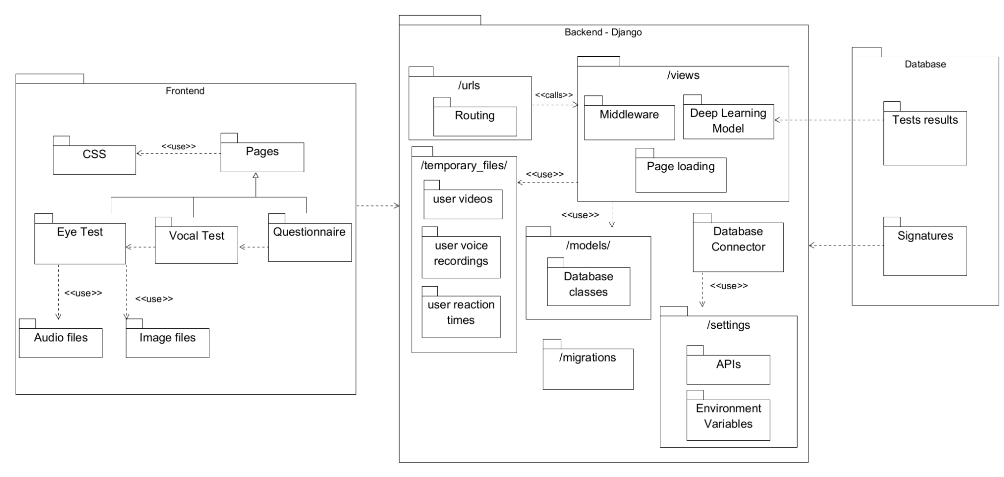

**Figure 1:** The provided diagram represents the overall architecture of our system, organized into three main components: the Frontend, the Backend (Django), and the Database.

* **Frontend:** This section represents the user interface and interaction layer of the system. It includes three primary tasks: the Eye Test, Vocal Test, and Questionnaire, each responsible for specific user interactions. The Pages module manages the layout and content, with CSS handling the styling. The Eye Test and Vocal Test components utilize audio and image files respectively, to guide the user through the tasks. The Questionnaire is directly integrated within the frontend, allowing users to input their responses.
* **Backend (Django):** This section handles the core logic and data processing of the system. The architecture is modular, with clear separation between routing, views, models, and settings. The urls module manages routing, directing requests to the appropriate views. The views module handles the main logic, including page loading, middleware processing, and integration with the Deep Learning Model. Temporary files, such as user videos, voice recordings, and reaction times, are stored in the /temporary_files/ directory for short-term processing. The models module defines the structure of the database classes, while the Database Connector facilitates interaction with the database. The settings module manages APIs and environment variables crucial for the system’s operation.
* **Database:** This section stores the persistent data necessary for the system’s functioning. It includes Test Results, which records the outcomes of the user’s tests, and Signatures, which may be used for authentication or verification purposes. The database is tightly integrated with the Backend, allowing for seamless data storage and retrieval.

## **8.2 System Activity Diagrams**

This section provides a detailed representation of the system’s behavior and user interactions through a series of UML activity diagrams. These diagrams illustrate the sequence of actions taken by both the user and the system, highlighting key decision points, data flows, and process transitions. The activity diagrams are organized to capture different aspects of the system’s operation, from user input to data processing and result generation. By visualizing these workflows, we can better understand the system’s logic and ensure that all components interact smoothly to achieve the desired outcomes. The diagrams are particularly useful for identifying potential bottlenecks, improving system efficiency, and documenting the procedural flow of activities within the system.

These diagrams collectively provide a comprehensive view of the system's operational flow and serve as a crucial tool for analysis, design refinement, and effective communication of system behavior.

**Figure 2:** System Flow Activity Diagram - Depicts the overall system flow from the user’s initiation of a test to the display of results.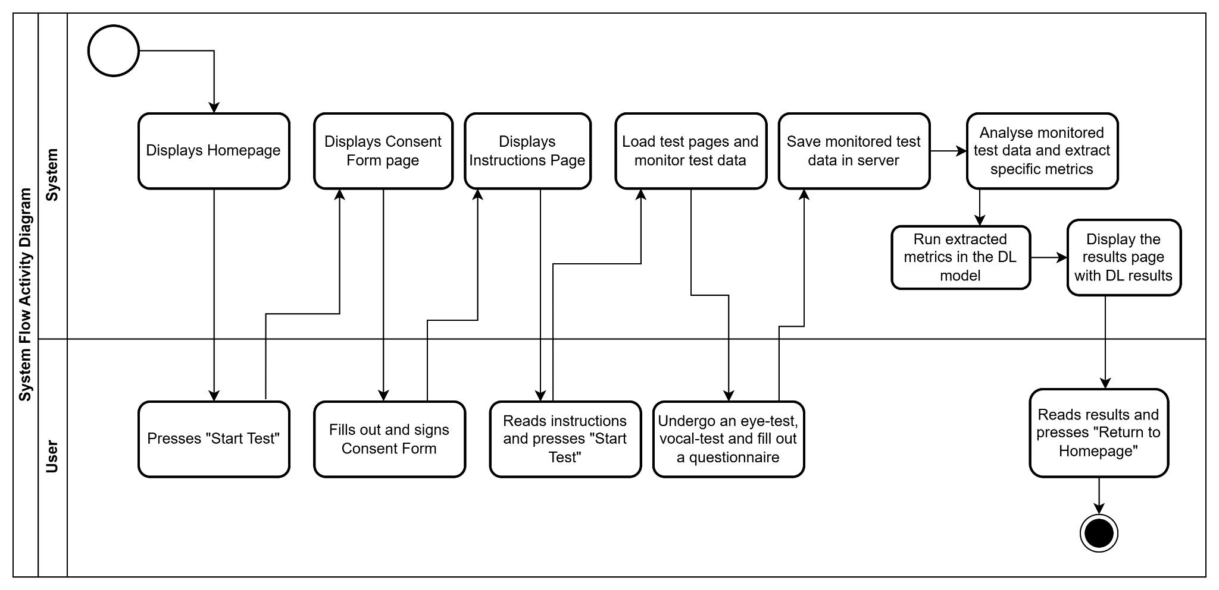

This diagram outlines the overall flow of actions between the user and the system during the test process. The user begins by pressing "Start Test," which triggers a series of system responses, including displaying the homepage, consent form, and instructions page. After the user consents and reads the instructions, they undergo the eye test, vocal test, and complete the questionnaire. The system monitors the data throughout the test, saving it to the server and analyzing it to extract specific metrics. These metrics are then processed through the deep learning model, and the results are displayed to the user. Finally, the user reviews the results and has the option to return to the homepage. This diagram effectively captures the end-to-end interaction between the user and the system, highlighting the key actions and decision points that occur during the test process.

**Figure 3:** Data Acquisition and Model Training Activity Diagram - Shows the process of collecting user data, analyzing it, and using it to train and refine the deep learning model.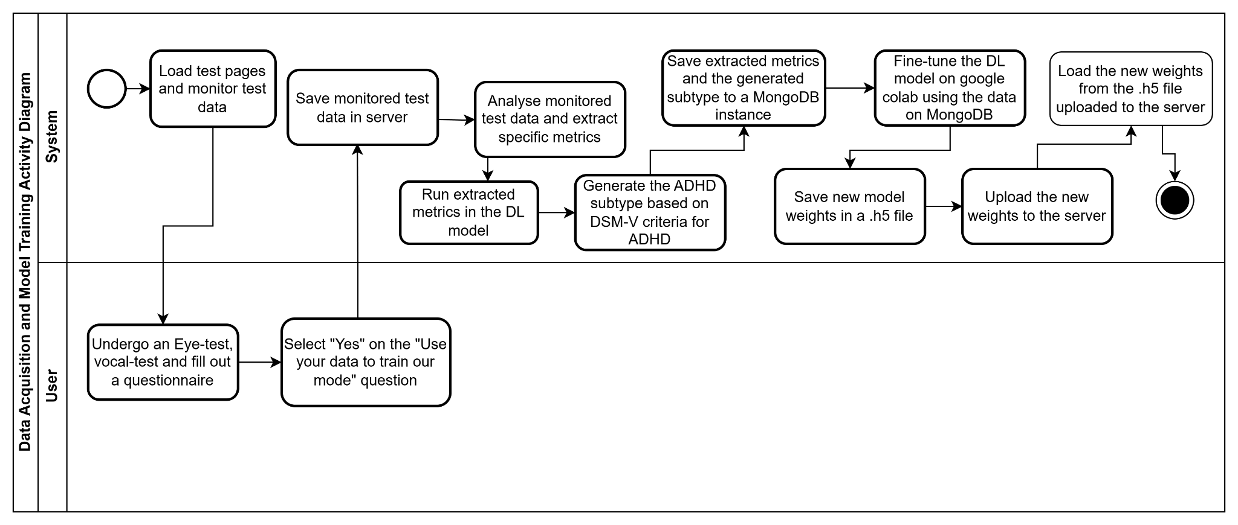

This diagram illustrates the data acquisition and model training process, detailing how user data is collected, analyzed, and utilized to refine the deep learning model. The process begins with the user undergoing the eye test, vocal test, and questionnaire. The system then monitors and saves the test data, extracting relevant metrics that are subsequently processed through the deep learning model. If the user consents to contribute their data for model training, the system generates an ADHD subtype based on DSM-V criteria and saves the data to a MongoDB instance. The model is then fine-tuned using this data, and the updated model weights are saved and uploaded to the server for future use. This diagram captures the iterative process of data-driven model improvement, emphasizing the feedback loop between data acquisition and model refinement.

**Figure 4:** Test Flow Activity Diagram - details the specific interactions and processes involved in conducting the eye test, vocal test, and questionnaire.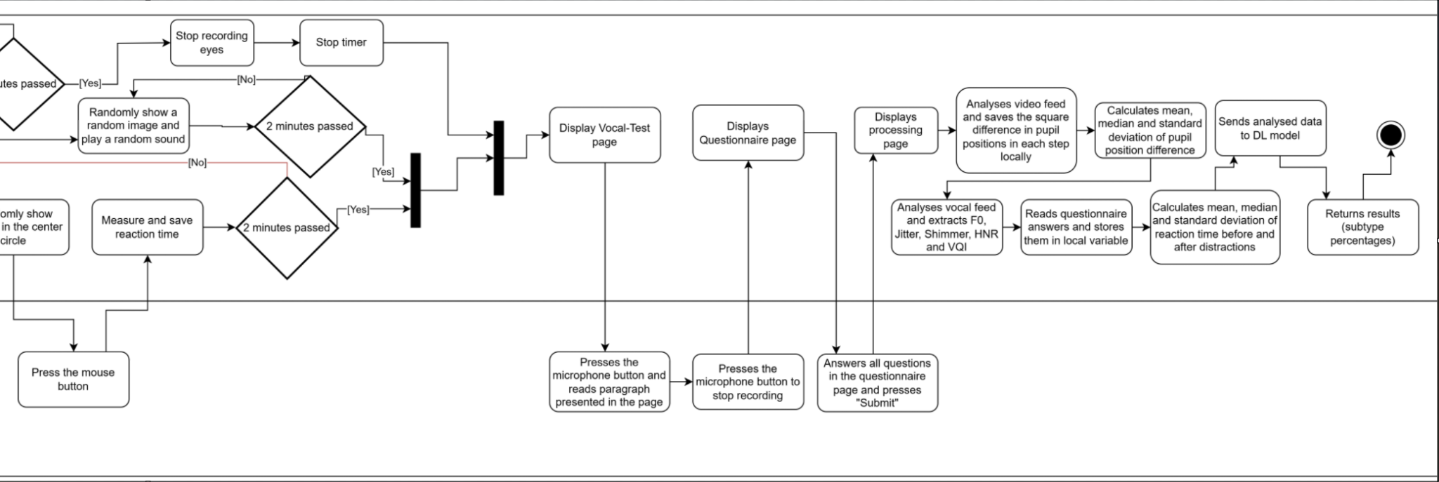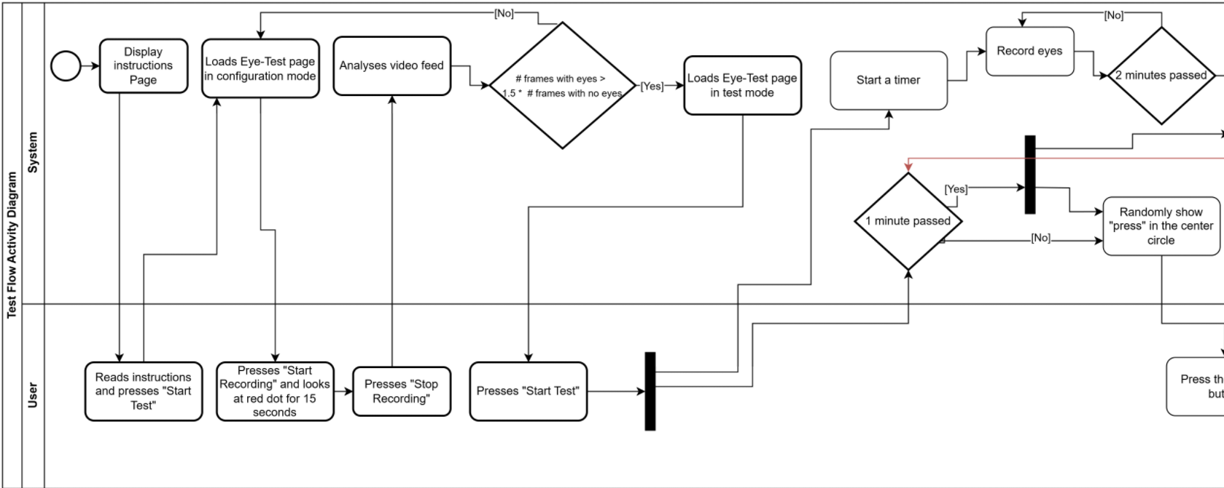

This diagram provides a detailed view of the test flow, focusing on the execution of the eye test, vocal test, and questionnaire. It begins with the system displaying the instructions page, followed by loading the eye-test page in configuration mode. The user then presses "Start Recording" to initiate the eye test, during which they must focus on a red circle for a set duration. The system analyzes the video feed in real-time, records eye movements, and introduces distractors to measure reaction time. After the eye test, the system proceeds to the vocal test and questionnaire. The collected data is processed to calculate various metrics, which are then analyzed and sent to the deep learning model for further evaluation. This diagram highlights the intricacies of the testing process, emphasizing the steps taken to ensure accurate data collection and analysis.

## **8.3 System Interface**

This section presents a series of images and screenshots that showcase the various components and functionalities of our system. Each visual representation is accompanied by a detailed explanation, illustrating the step-by-step process that users experience when interacting with the system.

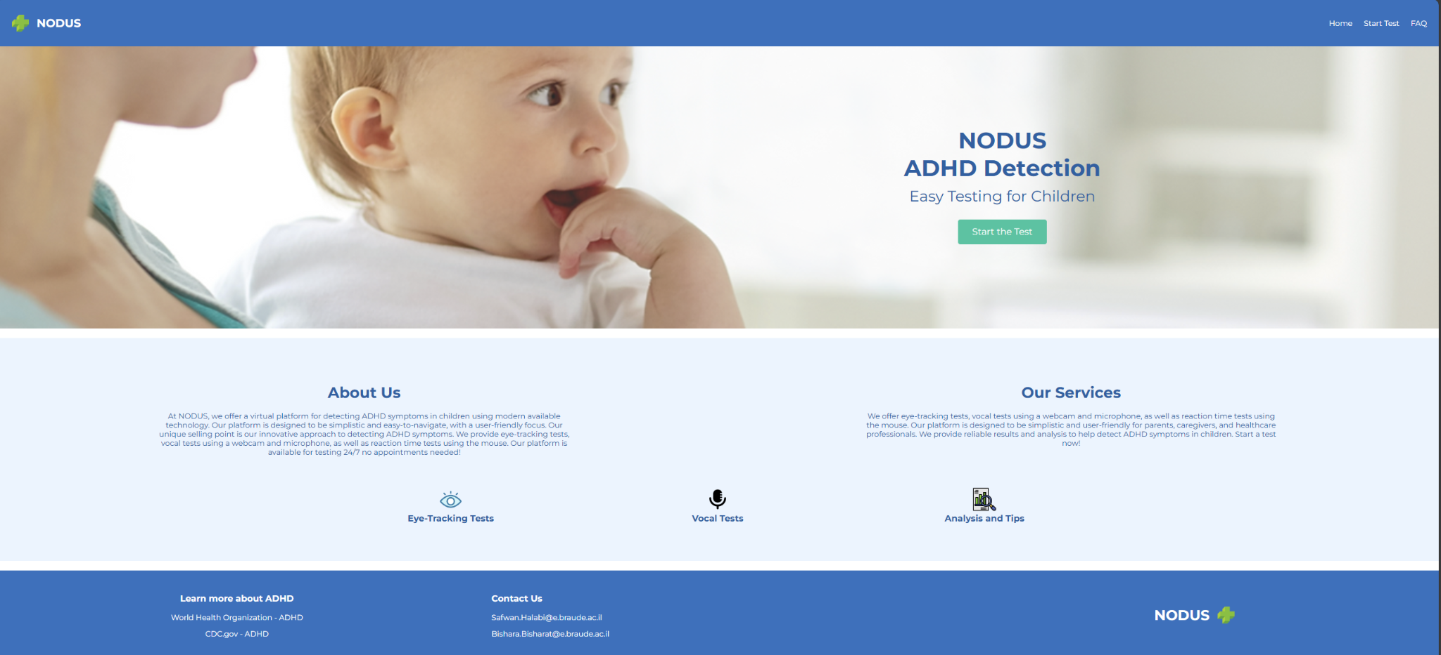

**Figure 5:** Image of our homepage, it has a navbar with 3 options: “Home”, “Start Test” and “FAQ”. Additionally the page has general info about the system and our contact information, as well as external links with information about ADHD.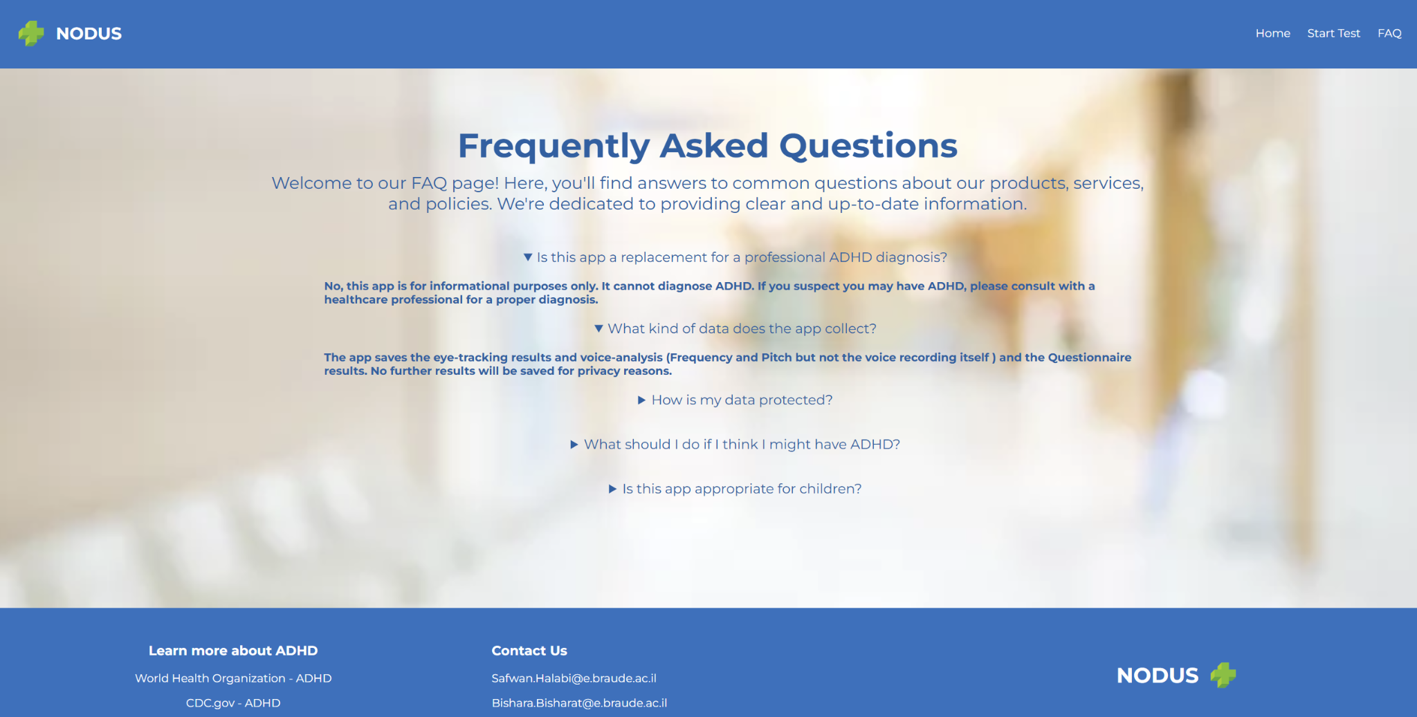

**Figure 6:** Image of our Frequently Asked Questions page.

The FAQ page features five common questions related to the system’s functionality, purpose, and usage. Each question is displayed in a collapsible format, allowing the user to click on a question to reveal the corresponding answer. This design ensures that the page remains uncluttered and user-friendly, providing information on demand without overwhelming the user. The questions cover essential topics, such as common concerns, data privacy, and how the results should be interpreted. By addressing these frequently asked questions, the page serves as a helpful resource for users seeking clarification on various aspects of the system.

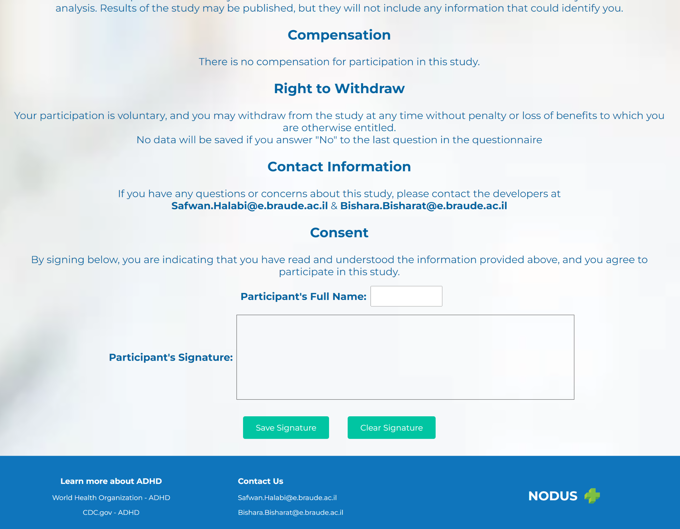

**Figure 7:** Part of our consent form page.

This figure showcases the Consent Form page, where users are required to provide their full name and digital signature to confirm their agreement to participate in the study. The consent form is a crucial component of the project, ensuring that participants are fully informed about the study’s purpose, procedures, risks, and their rights.

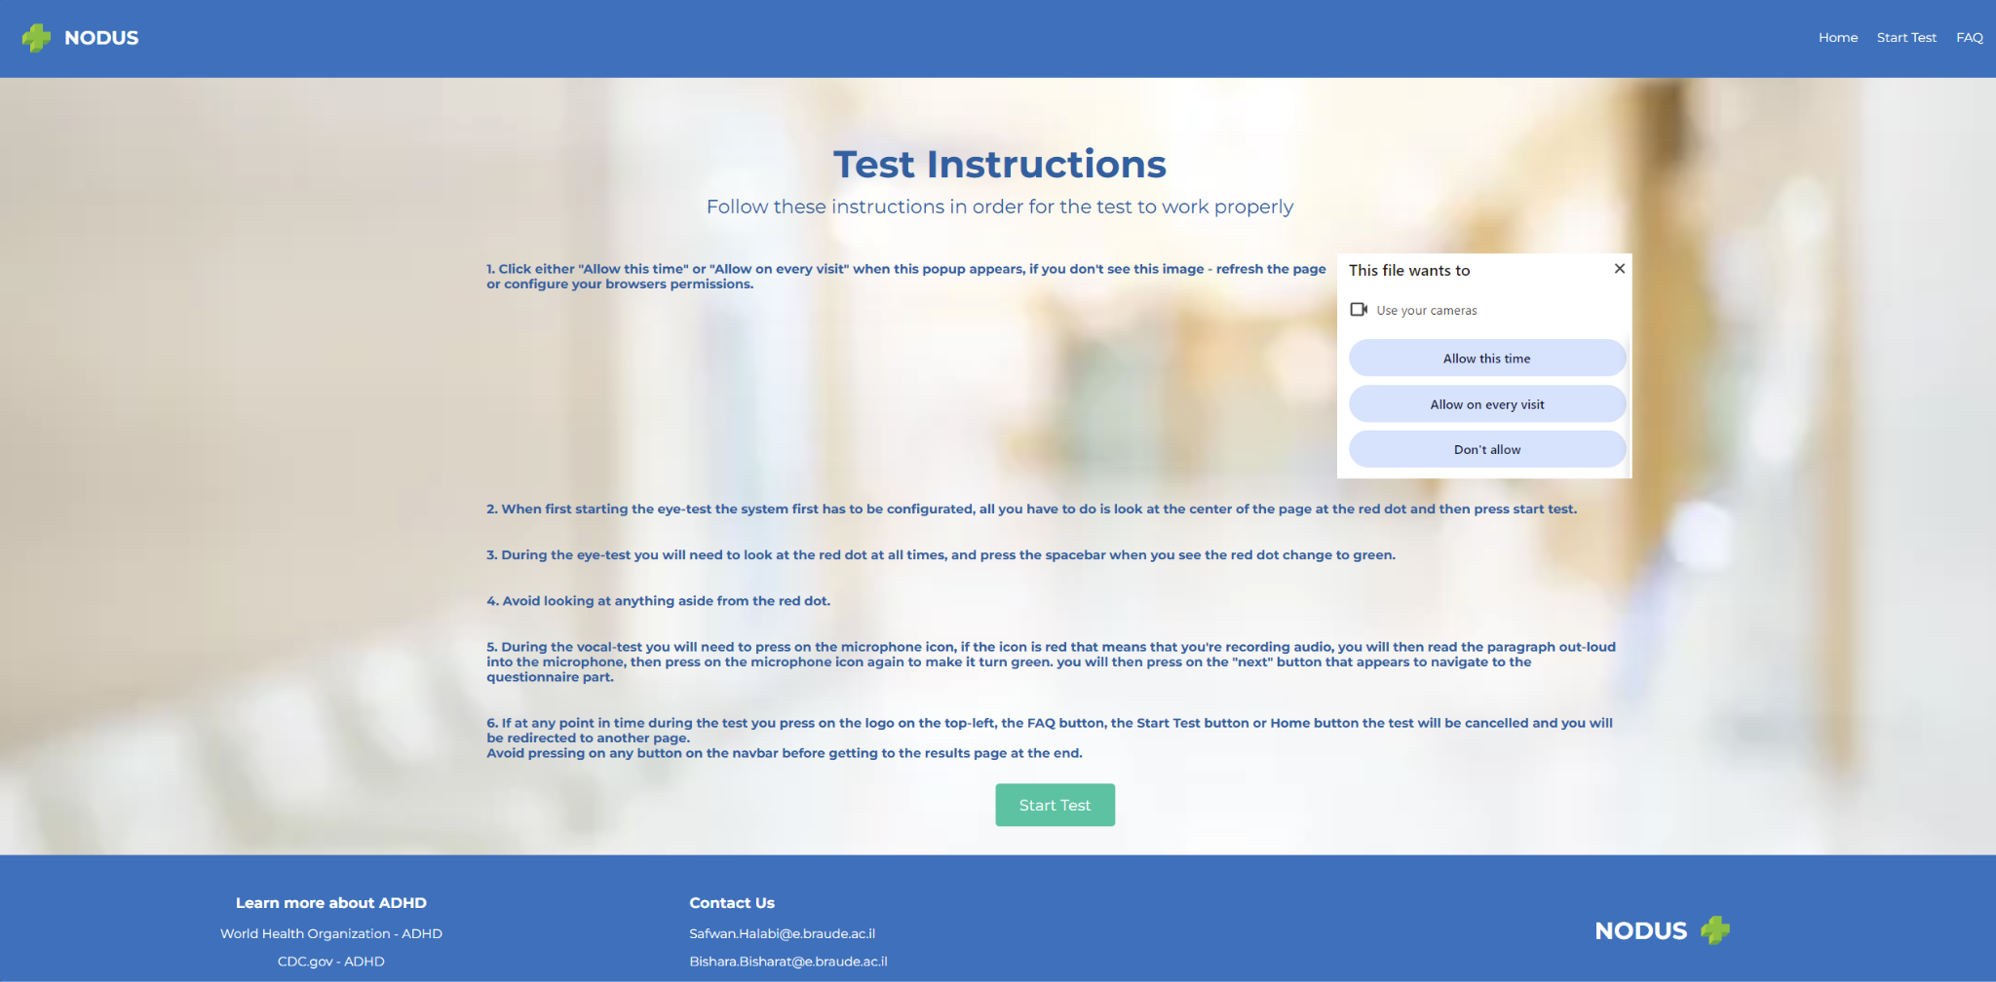

**Figure 8:** Image of our test instructions page

The Test Instructions page provides users with step-by-step guidance on how to complete the eye-tracking, vocal, and questionnaire tasks in the system. It includes instructions on allowing camera access, configuring the eye-test, maintaining focus during the test, and properly recording audio during the vocal test. The page also warns users against navigating away from the test to avoid cancellations. By following these instructions, users can ensure accurate data collection and a smooth testing experience.

**Figure 9**: Image of the calibration part prior to the eye-tracking test.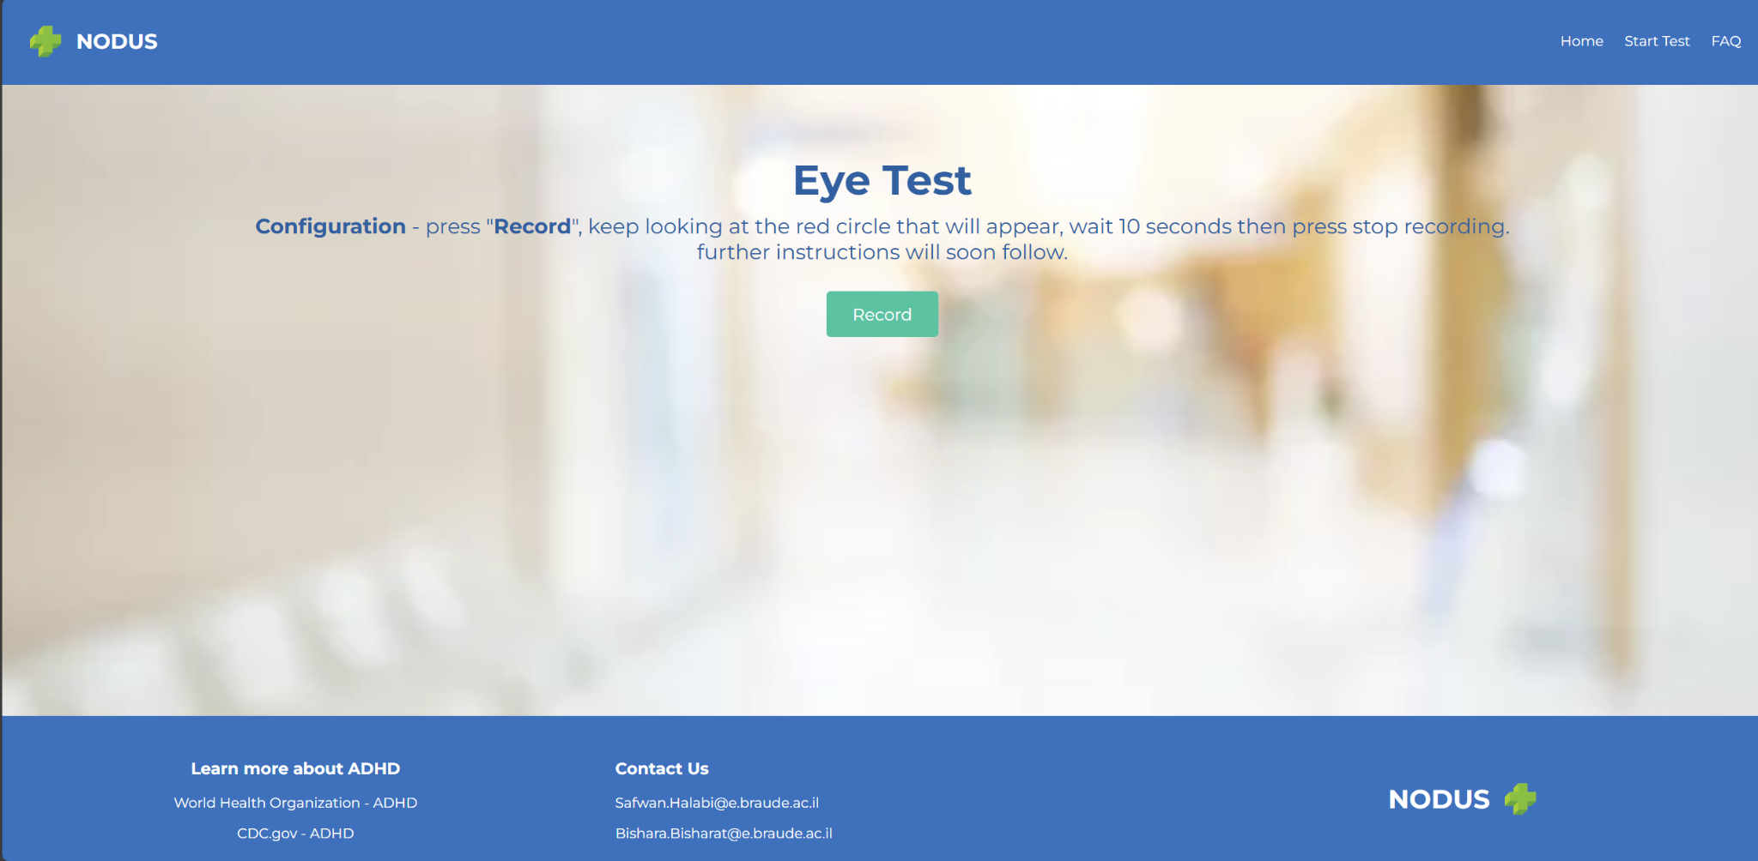

**Figure 10**: Images of our eye-tracking test, this is how the test looks like, the user will have to look at the red circle for the entire duration of the test, occasionally the user will be asked to press the mouse button if the “press” appears in the circle.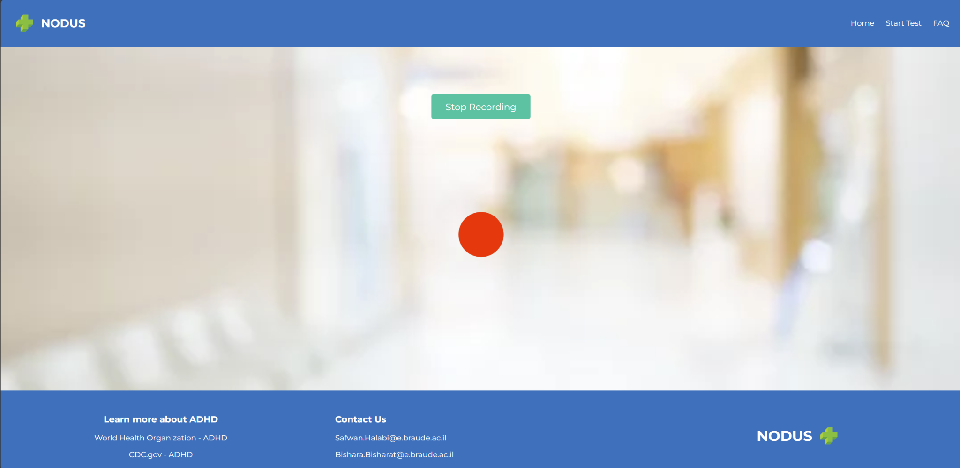

**Figure 11**: Image of the vocal test page.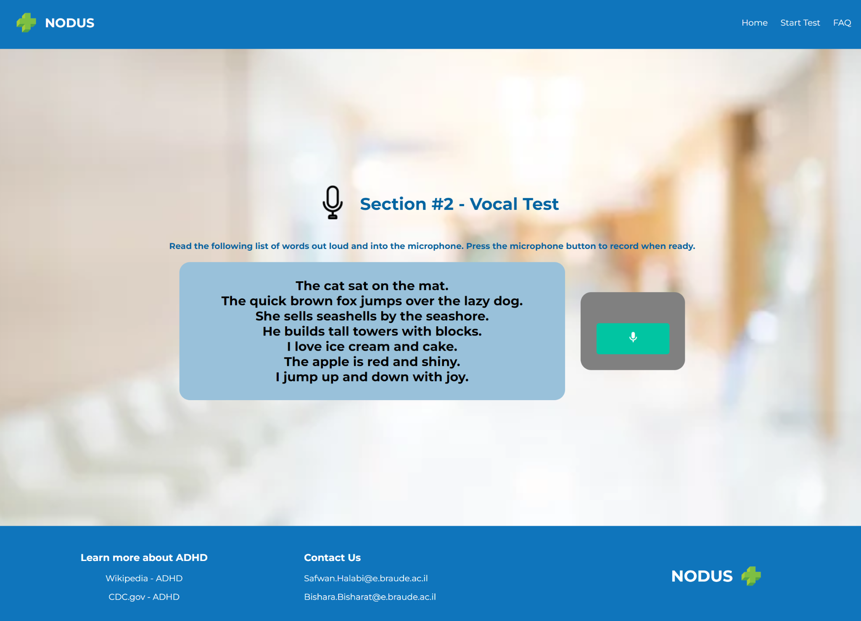

The Vocal Test page instructs the user to read aloud a series of sentences into the microphone. The user begins and ends the recording by pressing a large green button. The sentences are designed to capture a range of vocal characteristics, which the system analyzes to extract relevant features for ADHD detection. The page also provides clear instructions and contact information, ensuring a smooth and informative user experience.

**Figure 12:** Image of our questionnaire page.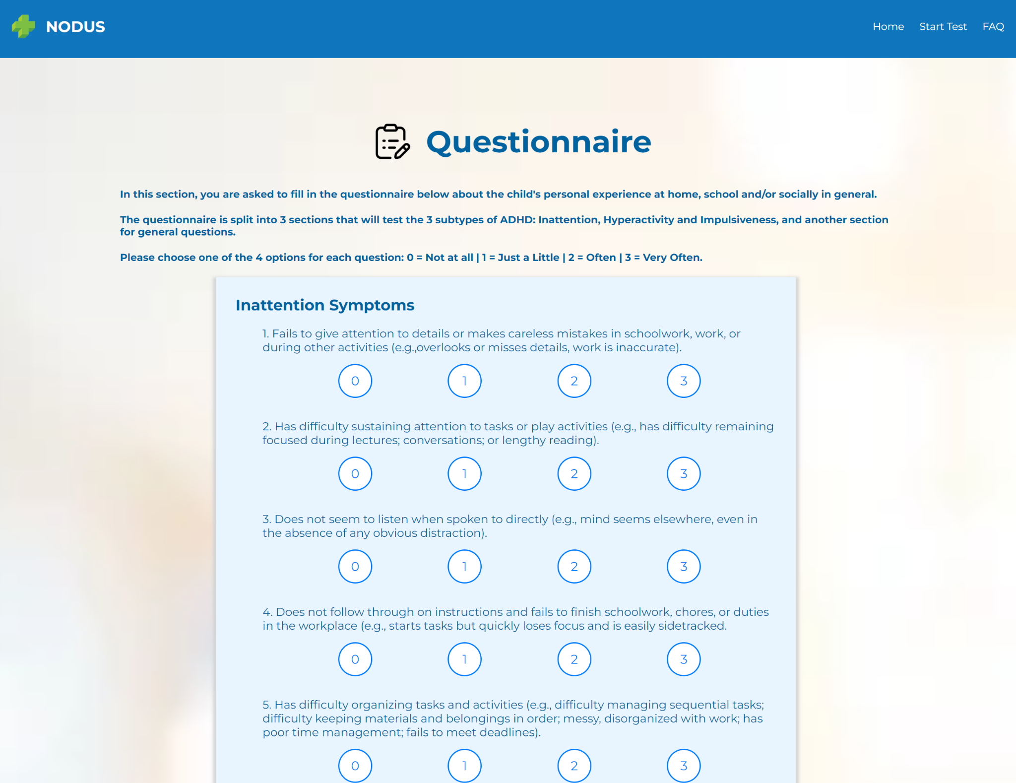

This page features a questionnaire designed to assess symptoms of ADHD. It includes 20 questions, with responses ranging from 0 to 3, or simple Yes/No answers. The questions are divided into sections that evaluate different aspects of ADHD, including inattention, hyperactivity, and impulsiveness. Users are required to complete all questions, which will be used by the system to provide a comprehensive evaluation.

**Figure 13:** Image of our results page.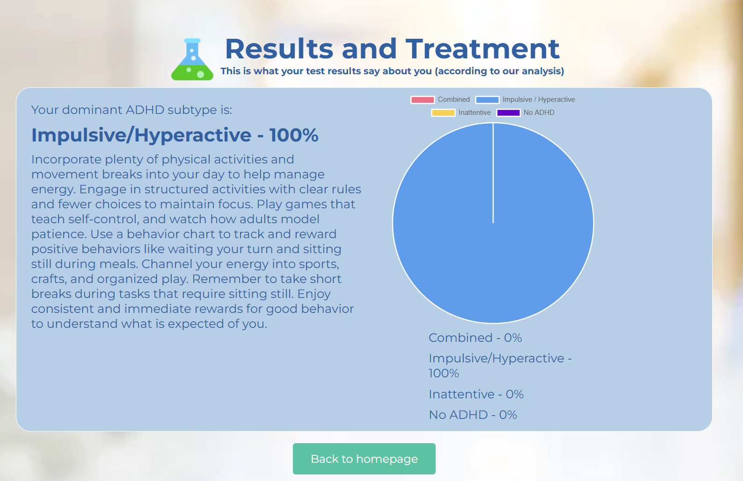

This page displays the user's dominant ADHD subtype based on the system's analysis. The text, which provides tailored advice and recommendations, changes according to the subtype with the highest percentage. A pie chart visually represents the distribution of the subtypes, with the dominant subtype highlighted. The user can return to the homepage by clicking the "Back to homepage" button.

It should be mentioned that there is another page that the user will see before this one, it's a static page that says that the back-end received your audio recordings and videos and questionnaire answers and is currently analyzing them, so the user is asked to wait.

# **9. Challenges and Obstacles**

In this section, we outline the key challenges and obstacles encountered during the development and implementation of our system. These challenges span various aspects of the project, including technical limitations, data collection difficulties, and integration issues. To provide a clear and organized analysis, we have divided this section into multiple subsections, each addressing a specific category of challenges and the strategies we employed to overcome them.

## **9.1 Data Availability**

As mentioned earlier in the book, we found several tests that are similar in spirit to the tasks we implemented in our system, but there were some key differences that prevented us from using their test data outright. Given that the market for ADHD detection systems is scarce, we naturally found it difficult to find meaningful, concrete data to train our model with, even after spending a great deal of time on this particular problem.

Eventually, we settled on the idea of acquiring data in-house through multiple experiments on patients with ADHD and subjects without ADHD. However, this approach presented challenges in participant recruitment, particularly in finding a diverse set of participants, especially those with confirmed ADHD diagnoses. This limitation may have impacted the generalizability of our results, as our data set was not as varied as we initially hoped.

Additionally, maintaining data consistency across different sessions and participants proved challenging. Variations in attention levels and cooperation among participants introduced inconsistencies that had to be carefully managed to ensure the data remained reliable. Despite these challenges, the data we collected was saved to a database and later used to train our Deep Learning model, forming the foundation for our system's analysis.

## **9.2 Working with a Virtual Environment**

While working within a virtual environment facilitated development, it also introduced challenges, particularly when managing dependencies and ensuring compatibility across different systems. We encountered several issues related to environmental dependencies, which required us to go through multiple revisions of the technologies used. These issues arose from differences between our personal computers, as well as discrepancies between the Python versions we used locally and the version required by our deployment provider.

Resolving these challenges demanded comprehensive compatibility tests across all our devices. Through this iterative process, we were able to identify a configuration that worked consistently across all environments. This ensured that the development, testing, and production environments remained aligned, allowing us to avoid conflicts between libraries and maintain stability throughout the project. Ultimately, finding a suitable version that accommodated everyone’s setup was key to successfully deploying and running our system.

## **9.3 Deployment**

One of the significant challenges we faced during the project was the deployment of our service. Initially, we utilized Amazon Web Services (AWS), specifically the Amazon Elastic Compute Cloud (EC2) web service, for deployment. While AWS offered a range of powerful features, the environment proved to be complex and difficult to manage. The deployment process was particularly challenging because it initially only supported HTTP, whereas our service required HTTPS for secure communication.

Additionally, AWS’s reliance on the EC2 instance posed a challenge, as our service could not be live 24/7 without the instance continuously running, which was not feasible for us due to the associated costs and maintenance overhead.

After encountering these obstacles, we explored alternative options and eventually decided to deploy on Render, which provided a more straightforward and user-friendly deployment process. Render's simplified environment significantly reduced the deployment time and made it easier for our team to manage the service. However, the switch to Render also introduced new limitations. Our website's speed and responsiveness are now constrained by our subscription plan, which, due to budget constraints, is currently set to the standard tier. This plan provides only 1 CPU and 2GB of RAM, limiting the website's performance and responsiveness, particularly during peak usage times. As a result, we were unable to achieve and maintain a site responsiveness time of less than 2 seconds all the time, which was one of our initial performance goals.

## **9.4 Integration of Multiple Components**

Integrating the various system components - such as the eye-tracking, vocal analysis, and questionnaire data - proved challenging due to the different formats, processing requirements, and timing considerations. Ensuring that these disparate data streams were synchronized and processed correctly required careful coordination and the implementation of robust data handling mechanisms.

Our development process added another layer of complexity. We began by developing the HTML pages separately, focusing first on the front-end design before connecting them through the back-end. This approach, while logical, introduced challenges in maintaining a cohesive design across all pages. Each team member was responsible for developing different HTML pages, which eventually led to conflicts in design principles, formatting, and user interface elements.

To resolve these issues, we engaged in discussions to establish several key design principles that each HTML page would need to adhere to. We agreed on a standardized format and layout, which allowed us to develop similar-looking pages simultaneously, even when working on different aspects of the project. This alignment not only helped maintain a consistent user experience but also streamlined the integration process, ensuring that all components worked together seamlessly in the final system.

## **9.5 Obstacles in Design**

Designing and planning the development of a system intended to be scalable presented its own set of challenges. From the outset, we needed to consider not just the immediate requirements of the project, but also how the system could be expanded or modified in the future. This required careful planning of the system architecture and structure, ensuring that it could handle increased demand, additional features, and potential integrations down the line.

Facing this obstacle wasn’t easy, as we had to go through several design iterations to land on a format that was not only scalable but also secure and functional. Several factors had to be taken into account, such as modularity, reusability, and maintainability of the codebase. We had to make deliberate choices about how to structure the system to avoid bottlenecks and ensure that it could scale efficiently as new requirements emerged. These considerations influenced everything from database design to the way we handled data processing and user interactions.

The need for scalability also meant that we had to anticipate potential challenges and build the system in a way that allowed for flexibility and adaptability. In summary, the design phase required a forward-thinking approach, balancing current needs with future possibilities, all while maintaining the integrity and performance of the system.

# **10. Experiment and Evaluation**

This section details the experiment conducted to collect the data used to train our Deep Learning model, as well as the evaluation and verification methods employed to ensure the system meets the predefined requirements. Following the experiment, the data was utilized to train the model, and the results, including the model's accuracy and performance metrics, are presented. The comprehensive analysis in this section confirms the system’s effectiveness in detecting ADHD symptoms, demonstrating the robustness of our approach through rigorous evaluation and validation.

## **10.1 Experiment**

The experiment conducted to gather data for training our Deep Learning model was carried out in three distinct phases, each designed to capture a diverse set of inputs under varying conditions. This approach ensured the robustness of the data and its applicability to real-world scenarios.

* **Phase 1: Supervised Testing with Colleagues**

The first phase involved physically setting up two copies of the then-current version of our system, along with two professional-grade microphones. A large number of our colleagues participated in this phase under our direct supervision. Each participant completed the full suite of tests, including the eye-tracking, vocal analysis, and questionnaire tasks. The test results were meticulously recorded, and the data for each participant was extracted and stored in our MongoDB database. To ensure accurate labeling, we used the participants' ADHD prescriptions where available. For those without a prescription, we assigned labels according to the DSM-V criteria for ADHD subtypes. This phase provided a solid foundation of supervised data, allowing us to observe participant behavior and verify the correct functioning of the system.

* **Phase 2: Mixed Supervision and Remote Testing**

The second phase of the experiment followed a similar setup but introduced a mixed approach to supervision. Once again, we used two copies of the system and two professional-grade microphones. This time, half of the participants completed the tests under our supervision, while the other half did so remotely from the comfort of their own homes. The goal of this phase was to compare data consistency between supervised and unsupervised settings. As in the first phase, we recorded all test data and labeled participants based on either their ADHD prescriptions or the DSM-V criteria. This mixed approach provided valuable insights into the reliability of remote data collection, ensuring that the system could function effectively even without direct supervision.

* **Phase 3: Fully Remote Testing**

The third and final phase was conducted entirely remotely, with participants completing the tests at home without any supervision. This phase was crucial for evaluating the system's performance in a completely unsupervised environment. Although we had no access to ADHD prescriptions for labeling in this phase, we applied our own metrics and criteria to assign subtypes based on the collected data. The test results were again recorded and saved to our MongoDB database, completing the data collection process.

The data from all three phases of the experiment now resides in our MongoDB instance, fully processed and ready to be fed into the Deep Learning model. By capturing data under varying conditions—supervised, mixed, and unsupervised—we ensured that the model would be trained on a diverse and representative dataset, thereby enhancing its generalization capabilities and overall accuracy.

## **10.2 Verification and Evaluation**

Ensuring the reliability and accuracy of our system was paramount throughout the development process. To this end, we conducted rigorous verification and evaluation procedures, encompassing a series of functional and acceptance tests designed to validate each component of the system. Our approach included thorough testing of all edge cases, with a specific focus on error handling to maintain a seamless user experience.

### **10.2.1 Functional Testing**

We performed functional tests on the system’s core modules, including input hardware, the web application, APIs, and the Deep Learning model. These tests ensured that the system met its functional requirements, with special attention given to the following areas:

* **Input Hardware:** We tested the system’s ability to access and process inputs from the user’s webcam, microphone, and mouse. The system successfully requested access to and received video input from the webcam, audio input from the microphone, and interaction data from the mouse, all as expected.
* **Web Application:** Several aspects of the web application were tested, including page load times, content display, and overall responsiveness. The system consistently loaded pages within 2 seconds, particularly after caching, and accurately displayed content across all key pages—home, FAQ, results, eye-test, vocal test, and questionnaire.
* **API Testing:** Our API tests focused on verifying the data flow between the front-end and back-end. We tested the system’s ability to send and receive data in JSON format, ensuring that video, audio, questionnaire, and signature data were accurately transmitted and processed by the back-end. For example, the Upload_video, **Upload_voice**, and **saveSignature** functions were successfully tested with corresponding files, confirming that data was properly handled at every step.
* **Deep Learning Model:** Verification of the Deep Learning model involved ensuring that it received the correct data for analysis. The model was tested with a composite string of data segments, including eye-tracking analysis, reaction-time data (both with and without distractions), vocal analysis, and questionnaire answers. The model successfully processed this input, ready for classification.

### **10.2.2 Acceptance Testing**

Beyond functional testing, we conducted a series of acceptance tests to confirm that the system met the predefined requirements. These tests included:

* **Correct Data Processing:** The model received all necessary inputs and executed its analysis correctly. Data consistency and accuracy were maintained across multiple test runs, ensuring reliable results.
* **Error Handling:** We meticulously checked all edge cases, ensuring that any errors encountered during operation would result in a user-friendly error message. In such cases, the user is notified via a popup and is redirected to the home page shortly after, preserving the system’s usability even in adverse conditions.
* **Accuracy Validation:** As part of our evaluation, we set a performance benchmark for the Deep Learning model, targeting an accuracy rate of over 80%. To validate this, we plan to test the model with data from individuals diagnosed with ADHD as well as a control group.

### **10.2.3 Summary of Key Acceptance Test Results:**

* **Input Hardware:** Webcam, microphone, and mouse inputs were accurately processed.
* **Web Application:** All pages loaded within the required time, displaying content correctly.
* **API:** Data was successfully sent to and received from the back-end.
* **Deep Learning Model:** Received the correct data structure for analysis.

Through these rigorous verification and evaluation processes, we ensured that each component of our system functioned correctly and met the necessary standards. This comprehensive testing framework not only validated the system’s functionality but also ensured its readiness for real-world deployment.

While our system met the majority of its functional and performance requirements, we identified several potential areas for improvement. Enhancing page load times could be achieved by either increasing deployment resources or optimizing the HTML pages for faster rendering. Additionally, further complexity could be introduced into the Deep Learning model to better capture intricate dependencies within the data, potentially improving the accuracy and robustness of the classification results. These enhancements would provide even greater efficiency and effectiveness as the system evolves.

## **10.3 Results**

The performance of our system was evaluated both during and after the model training process by employing the validation technique. In this approach, the training data was split into two groups: a training set and a validation set. The model was trained on the training set, while the validation set was used to compute the model's accuracy by comparing its predictions with the actual labels.

The advantage of using the validation set is that it provides the model with data it has not encountered during training, effectively simulating the introduction of new, unseen data. This approach allows us to assess the model's ability to generalize and its effectiveness in real-world scenarios.

Throughout the training process, our primary metrics for evaluating the model's performance were loss and accuracy. We also closely monitored validation loss and validation accuracy to assess the model's ability to generalize to unseen data, ultimately reaching a validation accuracy of 93.75%.

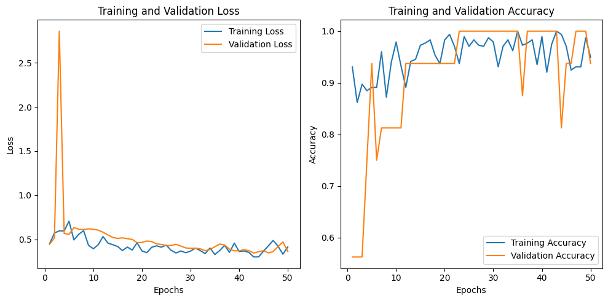

**Figure 14:** Results graphs showing accuracy and loss in training and validation.

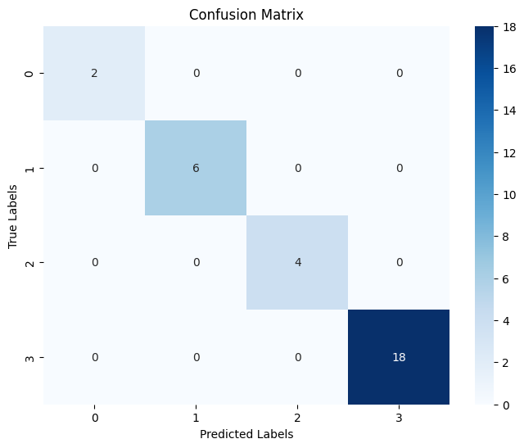

**Figure 15:** Confusion Matrix of the 30 validation cases we tested after training the model.

**Class 0** - Combined type, **Class 1** - Hyperactive type, **Class 2** - Inattentive type, **Class 3** - Control group with no ADHD.

The model ultimately achieved an **Accuracy value of 100%** (which can be attributed to the fact that our validation dataset only includes 30 cases), a **Precision value of 100%** for all classes and a **Specificity value of 100%** for all classes.

All the metrics we’re calculated using the Confusion Matrix values and the following equations:

$Accuracy= \frac{TP}{(TP+FP+FN+TN)}$

# $Precision= \frac{TP}{(TP+FP)}$

# **\* This metric is calculated per class**

# $Specificity = \frac{TN}{(FP+TN)}$**\* This metric is calculated per class**

# **References**

**[1]** Barona-Lleo, L., & Fernandez, S. (2016). Hyperfunctional voice disorder in children with Attention Deficit Hyperactivity Disorder (ADHD). A phenotypic characteristic?. Journal of Voice, 30(1), 114-119.

**[2]** Brock, S. E., Jimerson, S. R., & Hansen, R. L. (2009). Identifying, assessing, and treating ADHD at school. Springer Science & Business Media.

**[3]** D'Alatri, L., Petrelli, L., Calò, L., Picciotti, P. M., Marchese, M. R., & Bussu, F. (2015). Vocal fold nodules in school age children: attention deficit hyperactivity disorder as a potential risk factor. Journal of Voice, 29(3), 287-291.

**[4]** Edwards, J. H. (2002). Evidence-based treatment for child ADHD:" Real-world" practice implications. Journal of Mental Health Counseling, 24(2), 126-139.

**[5]** Garcia-Real, T., Diaz-Roman, T. M., Garcia-Martinez, V., & Vieiro-Iglesias, P. (2013). Clinical and acoustic vocal profile in children with attention deficit hyperactivity disorder. Journal of Voice, 27(6), 787-e11.

**[6]** Hamdan, A. L., Deeb, R., Sibai, A., Rameh, C., Rifai, H., & Fayyad, J. (2009). Vocal characteristics in children with attention deficit hyperactivity disorder. Journal of Voice, 23(2), 190-194.

**[7]** Lee, D. Y., Shin, Y., Park, R. W., Cho, S. M., Han, S., Yoon, C., ... & Kim, S. J. (2023). Use of eye tracking to improve the identification of attention-deficit/hyperactivity disorder in children. Scientific Reports, 13(1), 14469.

**[8]** Levantini, V., Muratori, P., Inguaggiato, E., Masi, G., Milone, A., Valente, E., ... & Billeci, L. (2020). Eyes are the window to the mind: Eye-tracking technology as a novel approach to study clinical characteristics of ADHD. Psychiatry Research, 290, 113135.

**[9]** Maniruzzaman, M., Shin, J., & Hasan, M. A. M. (2022). Predicting children with adhd using behavioral activity: a machine learning analysis. Applied Sciences, 12(5), 2737.

**[10]** Moodley, D. T., Swanepoel, C., Van Lierde, K., Abdoola, S., & Van der Linde, J. (2019). Vocal characteristics of school-aged children with and without attention deficit hyperactivity disorder. Journal of Voice, 33(6), 945-e37.

**[11]** Orr, J. M., Miller, R. B., & Polson, D. M. (2005). Toward a standard of care for child ADHD: Implications for marriage and family therapists. Journal of Marital and Family Therapy, 31(3), 191-205.

**[12]** Perrin, J. M., Stein, M. T., Amler, R. W., Blondis, T. A., Feldman, H. M., Meyer, B. P., ... & Wolraich, M. L. (2001). Clinical practice guideline: treatment of the school-aged child with attention-deficit/hyperactivity disorder. Pediatrics, 108(4), 1033-1044.

**[13]** Ranjan, R., Naqvi, T., Mishra, P., & Gaur, S. S. (2022). Analysis Of Voice In Children Among ASD & ADHD-A Comparative Case Study. International Journal of Advance Research And Innovative Ideas In Education, 8(3), 667-673.

**[14]** Rucklidge, J. J. (2008). Gender differences in ADHD: implications for psychosocial treatments. Expert Review of Neurotherapeutics, 8(4), 643-655.

**[15]** Skogli, E. W., Teicher, M. H., Andersen, P. N., Hovik, K. T., & Øie, M. (2013). ADHD in girls and boys–gender differences in co-existing symptoms and executive function measures. BMC psychiatry, 13(1), 1-12.

**[16]** Yu, C. J., Du, J. C., Chiou, H. C., Chung, M. Y., Yang, W., Chen, Y. S., Fuh, M. R., Chien, L. C., Hwang, B., & Chen, M. L. (2016). Increased risk of attention-deficit/hyperactivity disorder associated with exposure to organophosphate pesticide in Taiwanese children. Andrology, 4(4), 695–705. https://doi.org/10.1111/andr.12183.

**[17]** Russell, A. E., Ford, T., Williams, R., & Russell, G. (2016). The association between socioeconomic disadvantage and attention deficit/hyperactivity disorder (ADHD): a systematic review. Child Psychiatry & Human Development, 47, 440-458.

**[18]** Bussing, R., Fernandez, M., Harwood, M., Wei Hou, Garvan, C. W., Eyberg, S. M., & Swanson, J. M. (2008). Parent and teacher SNAP-IV ratings of attention deficit hyperactivity disorder symptoms: psychometric properties and normative ratings from a school district sample. Assessment, 15(3), 317–328. https://doi.org/10.1177/1073191107313888.

**[19]** D. Kuang and L. He, "Classification on ADHD with Deep Learning," 2014 International Conference on Cloud Computing and Big Data, Wuhan, China, 2014, pp. 27-32, doi: 10.1109/CCBD.2014.42.



**Capstone Project Phase B**

**NODUS - Childhood ADHD Symptom Detection with Possible Solutions**

**User Guide**

safwanhalabi60@gmail.com

bish.150b@gmail.com

# **Table of Contents**

**Table of Contents 2**

**Introduction 3**

**Hardware Requirements 3**

**1. Preparation Pages 3**

1.1 Home Page 3

1.2 FAQ Page 4

1.3 Consent Form Page 5

1.4 Instructions Page 7

**2. Eye-Test Page 7**

**3. Vocal-Test Page 12**

**4. Questionnaire Page 15**

**5. Results Page 17**

# **Introduction**

In this book we will document and explain the flow of the Nodus system, detailing all the information that the user needs in order to use our product effectively.

We will divide this guide book into several sections, each detailing a core functionality of the system, along with the correct way to navigate and use it.

Alongside this guide book we also provide the user with a video guide showcasing the system, it can be found in the following link: [link to video guide](https://www.youtube.com/watch?v=bEg4kmK2Svg).

# **Hardware Requirements**

In order to use our system effectively you will need to have a working camera/webcam as well as a working microphone, the webcam has to be positioned in a way that captures the user’s face, no one else should be standing in the camera shot as it can disturb the eye-detection, make sure the room your in isn’t too lit or too dim as those factors can also disturb the eye/face detection.

# **1. Preparation Pages**

In this section we will explain all the pages that precede the tests, how to navigate them and what the user is asked to do in order to gain access to the test pages.

This section covers the following pages: Homepage, FAQ, Consent Form, and Instructions.

## **1.1 Home Page**

The Homepage is the landing page where users first interact with the system. It provides an introduction to the Nodus System, outlining its purpose and guiding users through the initial steps, this is what the page looks like:

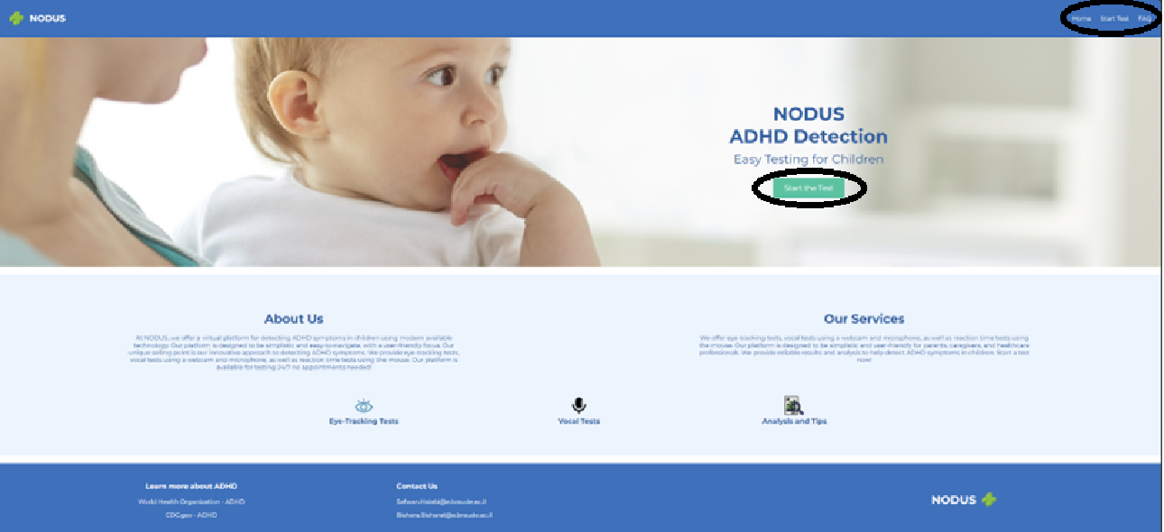

Input Fields and Actions:

* **Start Test Button:** This button directs the user to the Consent Form page. Clicking this button initiates the testing process.
* **Navigation Links:** Users can navigate to other sections such as the FAQ or Contact pages using these links.

Requirements:

The user does not need to input any information on the Homepage, but they must click "Start Test" to proceed.

## **1.2 FAQ Page**

The FAQ Page contains answers to the most common questions regarding the system. Each question is collapsible, allowing the user to view detailed explanations as needed, this is what the page looks like:

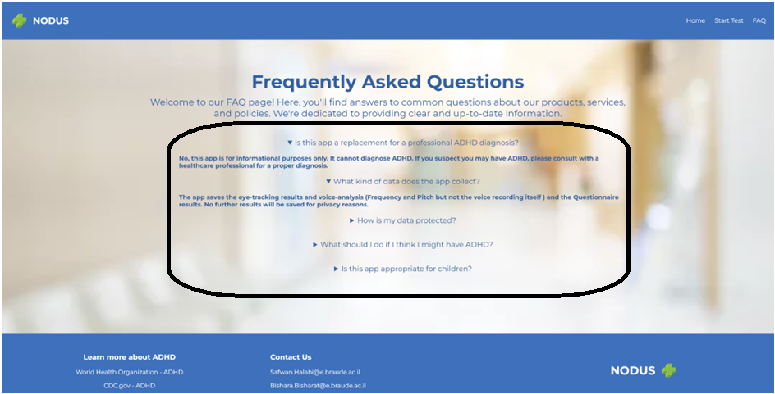Input Fields and Actions:

* **Question Tabs:** Clicking on a question expands it, revealing the answer. Users can click again to collapse it.

Requirements:

No specific input is required from the user; this page is informational only.

## **1.3 Consent Form Page**

The Consent Form page is a mandatory step where the user must agree to participate in the study. The form outlines the study’s purpose, procedures, risks, and the user’s rights, here is what the page looks like:

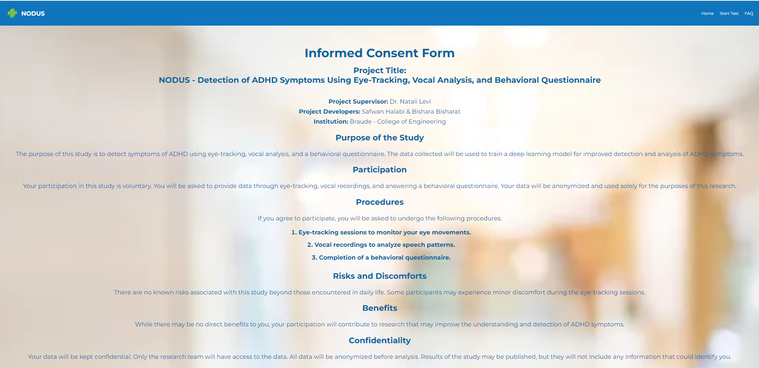

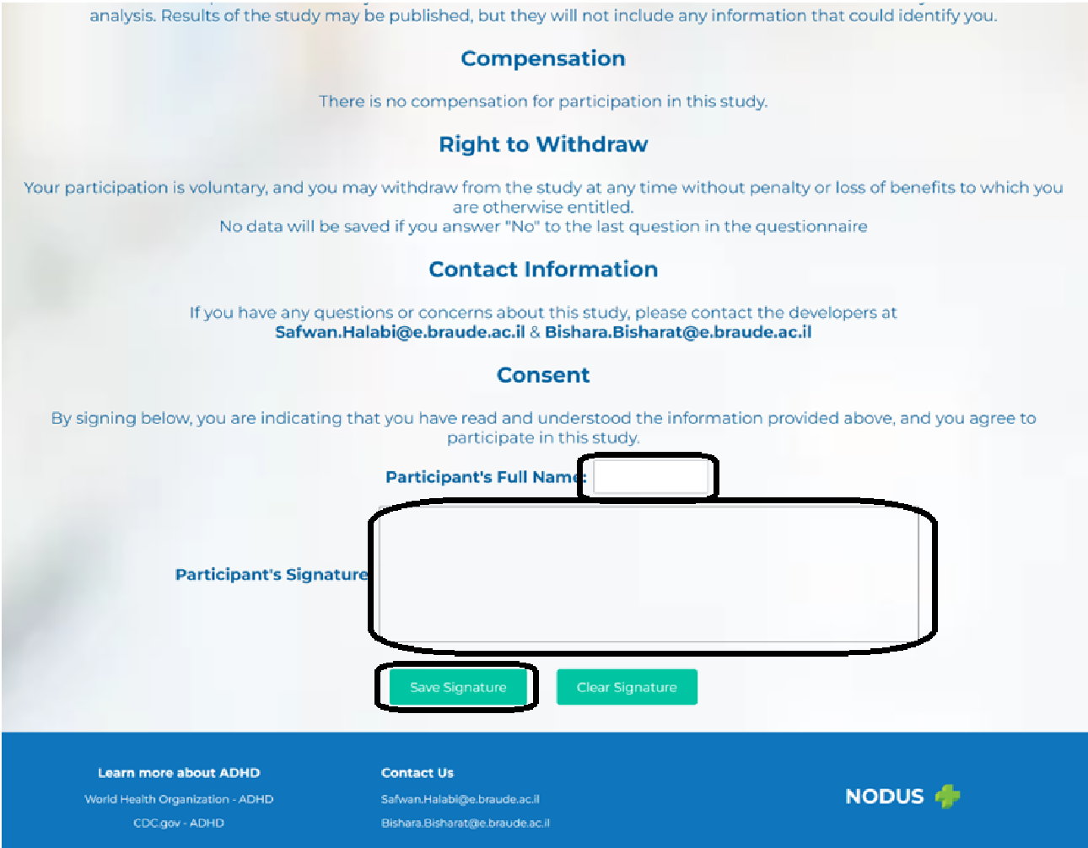

Input Fields and Actions:

* **Full Name:** The user must enter their full name as a digital signature.
* **Digital Signature:** The user provides their signature to agree to the terms.
* **Agree and Continue Button:** This button submits the consent and allows the user to proceed.

Requirements:

The user must provide accurate and complete information. The system will not proceed without a valid name and signature.

## **1.4 Instructions Page**

The Instructions Page provides detailed guidance on how to complete each part of the test. It ensures that the user understands how to interact with the system correctly, this is what the page looks like:

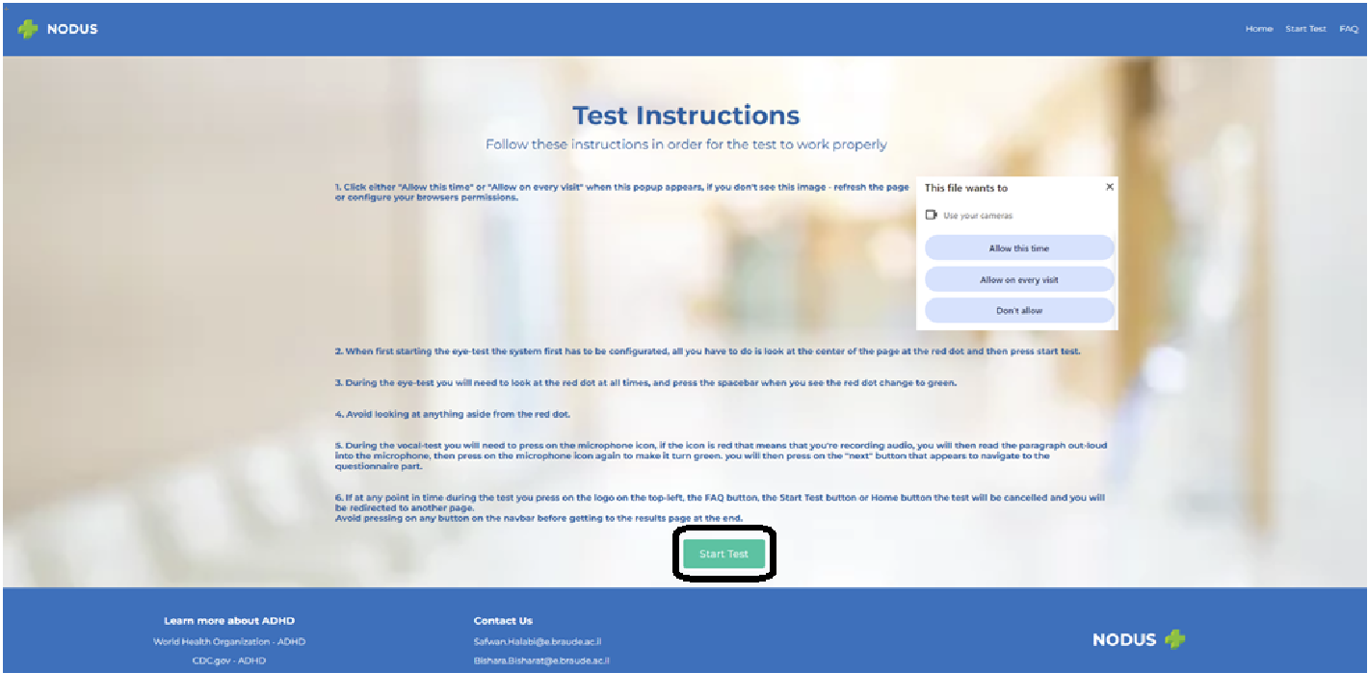

Input Fields and Actions:

* **Instructions Text:** The user must read and understand the instructions provided.
* **Start Test Button:** Once the user has reviewed the instructions, they click this button to begin the test.

Requirements:

The user must click "Start Test" to initiate the first task.

# **2. Eye-Test Page**

The Eye-Test Page is the first of the three main tasks in the system. It involves tracking the user's eye movements while they focus on a red circle displayed on the screen, there are instructions for this specific page on the screen, here is what the initial page looks like:

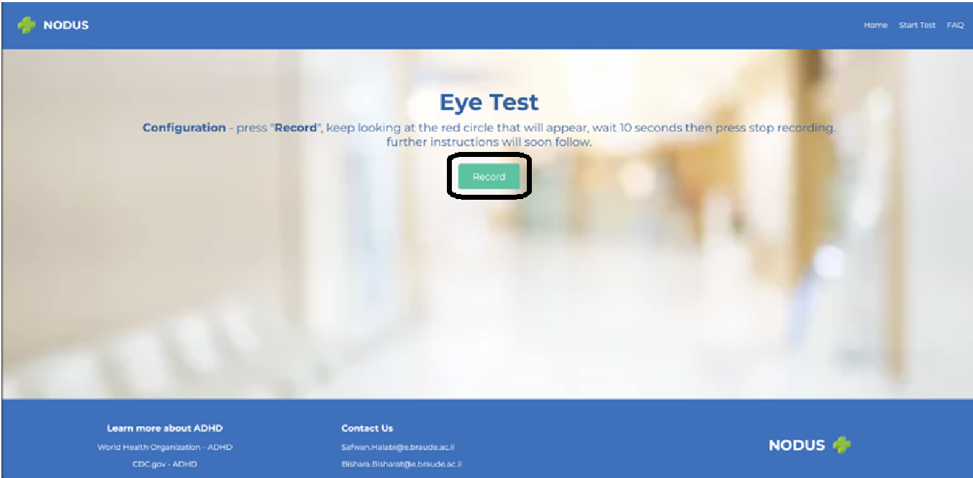

When the user first accesses this page he will be asked to start recording by pressing the “Start Recording” button, look at the red dot for about 15 seconds and then manually press the “Stop Recording” button to stop recording.

A permission prompt will pop up once the user presses “Start Recording”, the user will have to accept the prompt, here what the page will look like then:

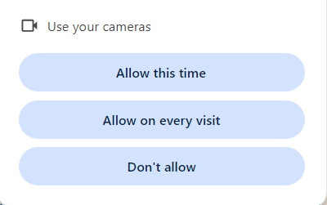

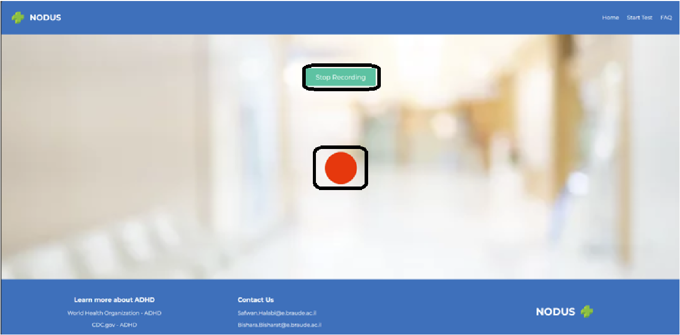

After which the user will be asked to wait a couple of seconds for the server to analyze the video feed the user sent, if the server recognizes the eyes of the user he will get a new prompt with new instructions to the actual test.

Here is what the page with the new prompt looks like:

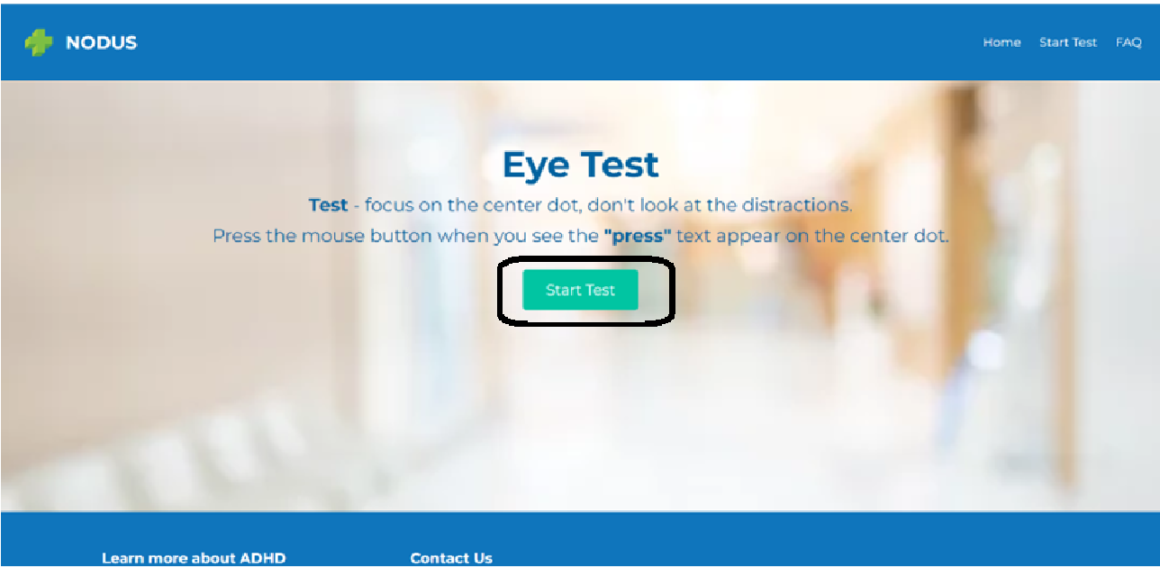

The test starts once the user press the “Start Test” button, the user will then be greeted with the same page he saw in the initial check, however now there is no need to manually stop recording as the test does that all by itself, the user will be asked to stare at the circle in the center of the page and occasionally press the mouse button if the word “press” appears in the middle of circle, nothing more.

The test ends automatically after 2 minutes, here is an image of the test:

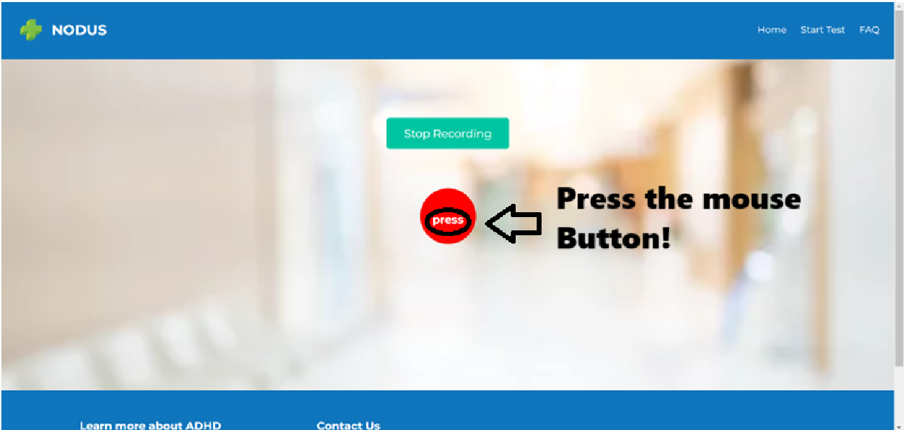

When all is said and done, the user will be greeted to a new page with instructions that states “Sending video to server, you will be redirected to the next page shortly”, here is what the page will look like then:

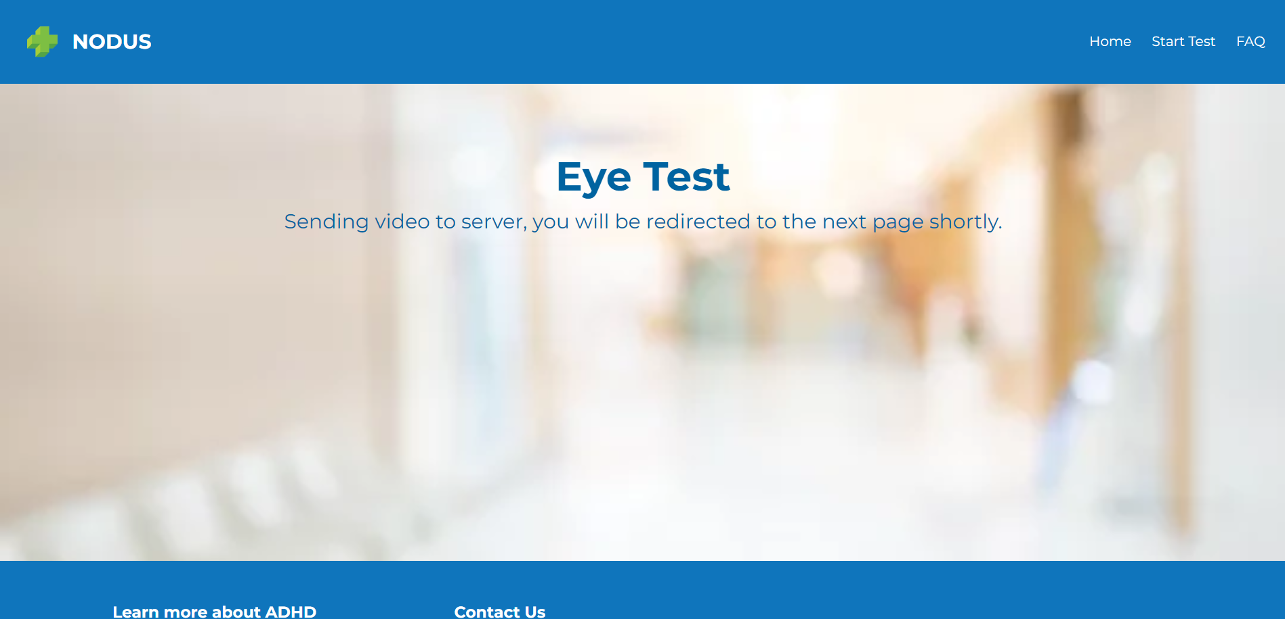

Input Fields and Actions:

* **Calibration:** Before starting, the user is prompted to focus on the red circle for calibration purposes.
* **Focus:** The user must keep their eyes on the red circle throughout the test.
* **Reaction Time:** When the word "press" appears, the user must quickly click the mouse button.
* **Distractor Phase:** In the second phase, the system introduces visual and auditory distractors, but the user must continue focusing on the red circle.

Requirements:

The user must maintain focus on the red circle and respond promptly to the "Press" prompt. Any deviation may affect the test’s accuracy as it is treated as an ADHD symptom.

# **3. Vocal-Test Page**

The Vocal-Test Page is the second main task in the system, designed to analyze the user’s speech patterns. The system records the user’s voice as they read a series of sentences displayed on the screen. This task is crucial for assessing vocal characteristics that may indicate symptoms of ADHD.

Upon reaching this page, the system will request access to the user’s microphone. The user must grant permission for the microphone to be used. If the permission request is denied, the user will not be able to proceed with the test, and the system will prompt them to enable microphone access, this is what that looks like: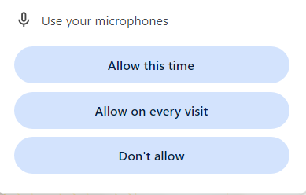

After granting microphone access, the user will see a green button with a microphone logo on it. Once the user clicks this button, the system will begin recording their voice. The recording interface will display a list of sentences for the user to read aloud.

The user should read each sentence clearly and at a steady pace. The sentences are designed to cover a range of speech patterns, so it is important that the user speaks naturally without rushing, this is what the page will look like then:

This is what the page will look like when the user starts recording audio: 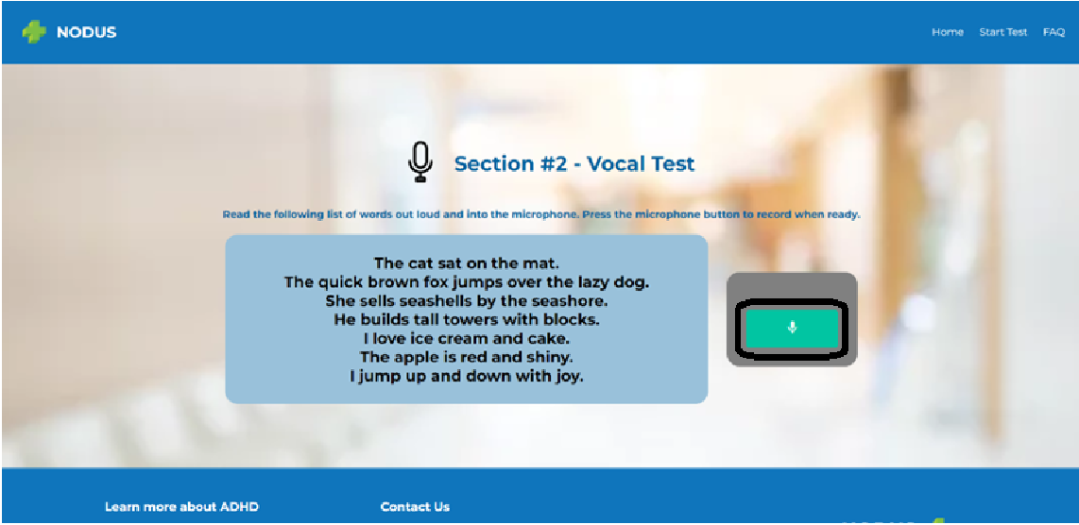

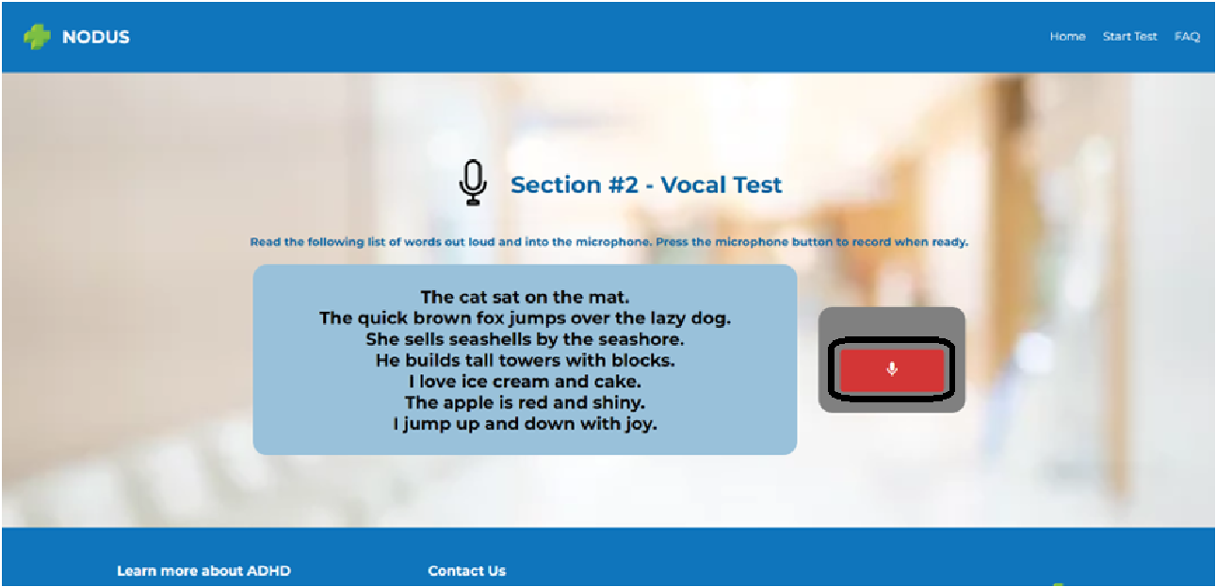

Notice how the microphone button turned red.

Once the user has finished reading all the sentences, they must click the “Stop Recording” button. The system will then show a button labeled “Next”, when the user presses it the audio-recording will be sent to the backend automatically, no prompt is shown to the user at this time and the page will redirect them automatically when the audio recording is saved successfully in the backend, here is what the page will look like then:

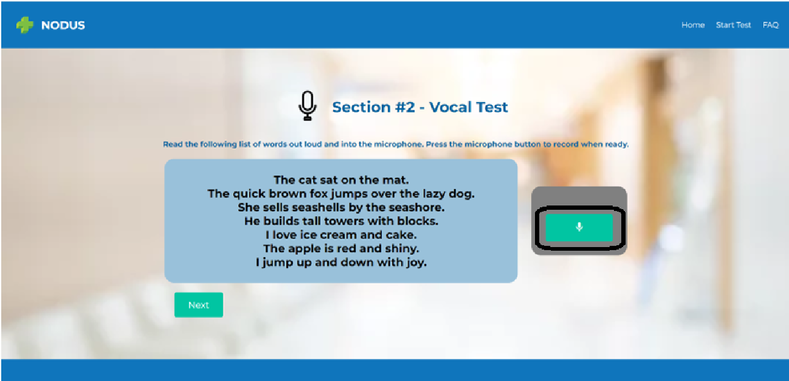

**Important Note:** If the user stops the recording too early or the audio quality is poor, the system may prompt them to repeat the task to ensure accurate data collection.

Input Fields and Actions:

* **Start Recording Button:** Initiates the recording of the user’s voice.
* **Stop Recording Button:** Ends the recording and sends the data to the server for analysis.
* **Microphone Permissions:** Required to access the microphone and record the user’s voice.

Requirements:

The user must speak clearly and read all the sentences displayed. Any hesitation, unclear speech, or poor audio quality may affect the accuracy of the analysis.

# **4. Questionnaire Page**

The Questionnaire Page is the final task in the Nodus System. It consists of 20 questions designed to assess the user’s behavioral tendencies, focusing on aspects that are commonly associated with ADHD. The responses provided by the user are a critical component of the overall evaluation.

At the beginning of the page the user will find an introduction to this page along with instructions.

Aside from that the questionnaire is divided into 4 distinct parts: questions about inattention symptoms, questions about hyperactivity symptoms, question about impulsiveness symptoms and 2 general questions at the end, here what the start of the questionnaire looks like: 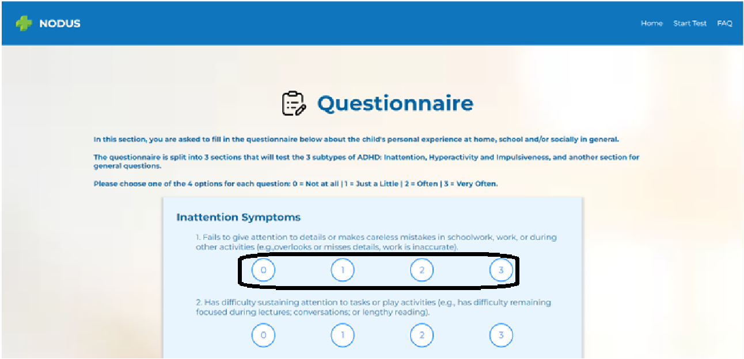

Here what the hyperactivity symptoms section looks like:

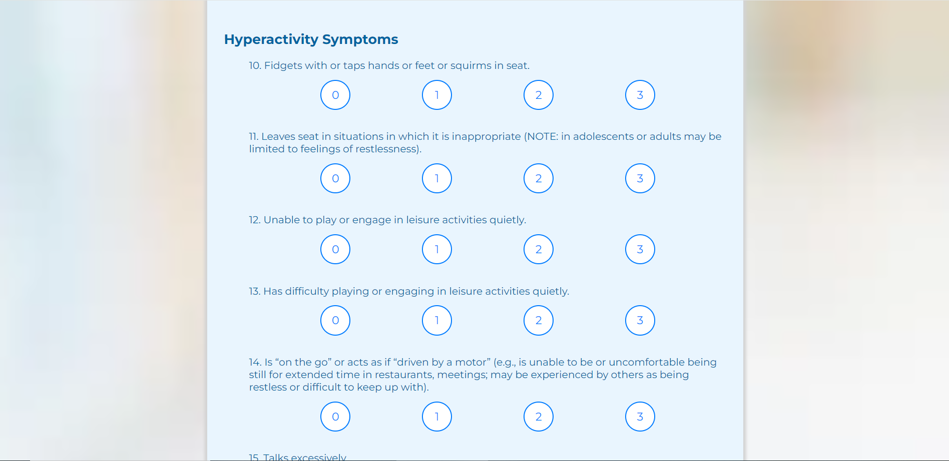

Here is what the impulsiveness symptoms section looks like:

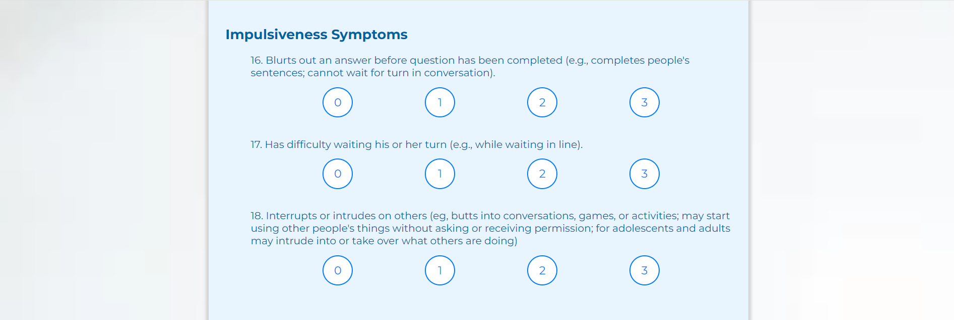

Here is what the general questions section looks like:

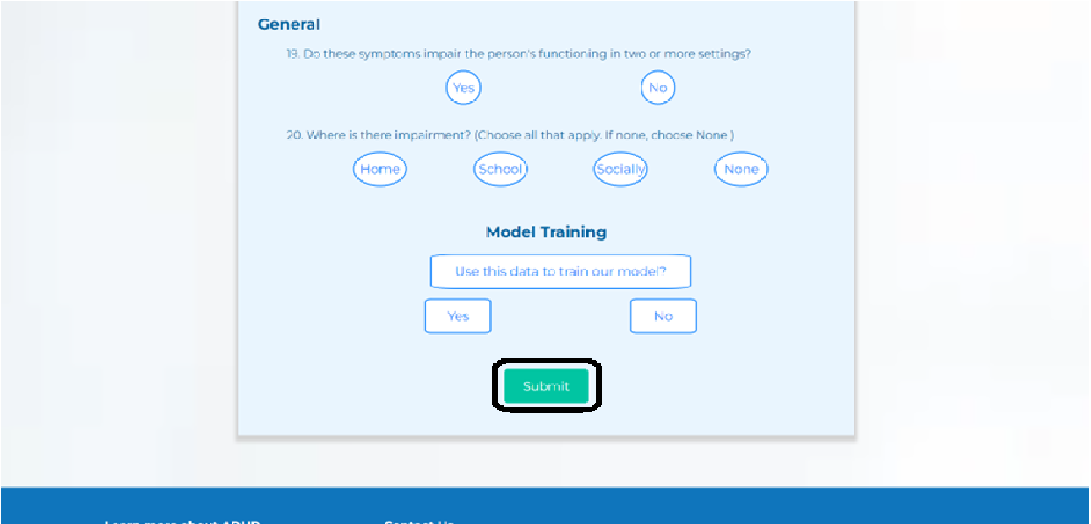

Once all questions have been answered, the user clicks the “Submit” button. The system will process the responses and incorporate them into the final evaluation.

**Important Note:** After submission, the user cannot change their answers. The system immediately begins processing the data to generate the results.

Input Fields and Actions:

* **Question Fields:** Each question requires a selection from multiple-choice options (0 to 3) or a Yes/No response.
* **Submit Button:** Finalizes the questionnaire and sends the responses for analysis.

Requirements:

The user must provide honest and accurate responses. The reliability of the overall assessment depends on the integrity of the data collected from this questionnaire.

# **5. Results Page**

This section involves 2 pages: the processing page and the results page. The processing page is called before the processing page and serves as a buffer that is shown to the user as our system analyzes the user’s test-results and prepares the final results page, this is page is static and does not allow the user to navigate back to any other page by normal means (excluding situations where the user manually closes the window or accesses another page by changing the URL). Here is what that page looks like:

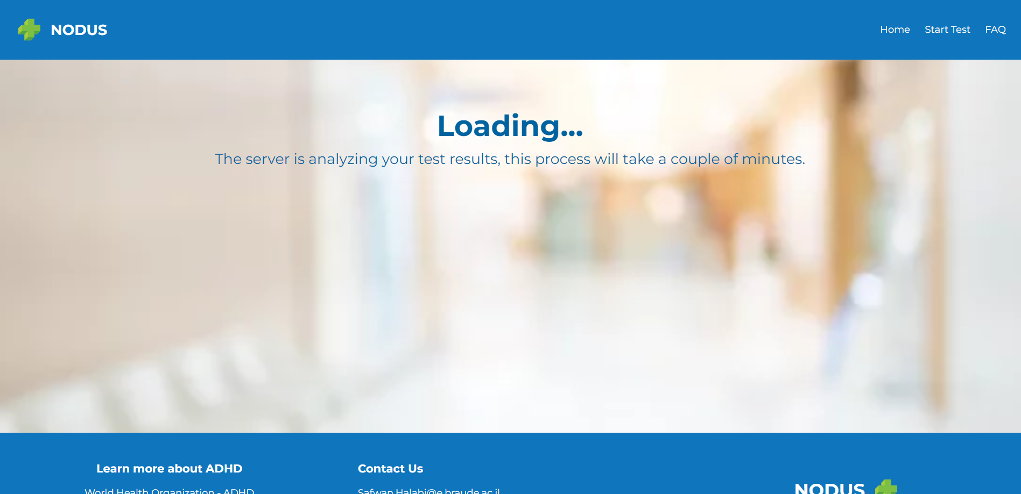

After going through the processing page the user will be greeted with the results page, which features a distribution of multiple ADHD subtypes and their respective percentages according to our model’s analysis and test-results, general tips to help the user deal with their detected subtype as well a button labeled “Back to homepage”, pressing said button will redirected to the homepage and all the data which was saved to our back-end will be flushed.

An image showing what the page looks like is provided on the next page.

This is what the page looks like:

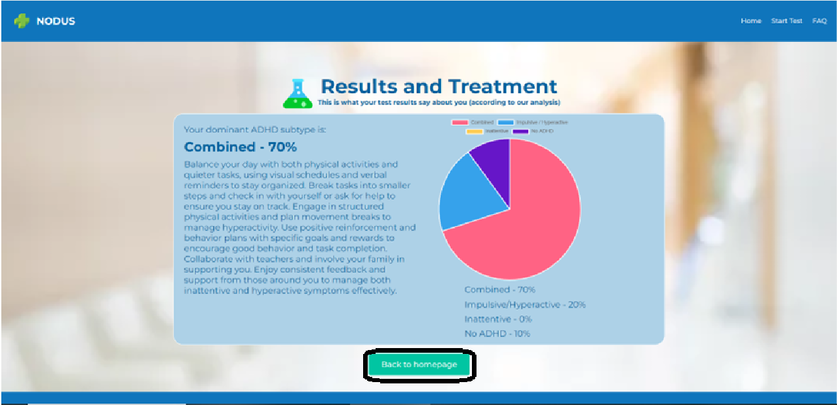

Input Fields and Actions:

* **Results Display:** Provides a visual and textual summary of the user’s ADHD classification.
* **Recommendations:** Offers personalized advice based on the user’s assessment.
* **Download Button:** Allows the user to save the results as a PDF.
* **Home Button:** Returns the user to the Homepage.

Requirements:

The user should carefully review the results and recommendations, no additional requirements are needed for this page.



**Capstone Project Phase B**

**NODUS - Childhood ADHD Symptom Detection with Possible Solutions**

**Maintenance Guide**

safwanhalabi60@gmail.com

bish.150b@gmail.com

# Table of Contents

**Table of Contents 2**

**Introduction 4**

**1. System Architecture Overview 4**

1.1 System Components 4

1.2 System Flow 6

**2. Software Dependencies 8**

2.1 Backend Dependencies 8

2.2 Environment Management 9

**3. Code Review 10**

3.1 manage.py file 10

3.2 db_connection.py file 10

3.3 FinalProject folder 10

3.3.1 settings.py file 11

3.3.2 __init__.py file 12

3.3.3 wsgi.py file 12

3.3.4 asgi.py file 13

3.3.5 urls.py file 13

3.4 ADHD folder 13

3.4.1 __pycache__ folder 14

3.4.2 migrations folder 14

3.4.3 signatures folder 14

3.4.4 static folder 14

3.4.5 templates folder 15

3.4.6 temporary_files folder 15

3.4.7 __init__.py file 15

3.4.8 admin.py file 15

3.4.9 apps.py file 15

3.4.10 models.py file 16

3.4.11 tests.py file 16

3.4.12 urls.py file 16

3.4.13 views.py file 17

**4. Back-end Code 18**

4.1 Deep Learning model 18

4.2 Render Functions 19

4.3 Data Processing Functions 20

4.4 Helper Functions 22

4.5 Database Functions 24

**5. Deployment 25**

5.1 Overview 25

5.2 Render dashboard 25

5.3 The control panel 26

5.3.1 Events 26

5.3.2 Logs 26

5.3.3 Environment 27

5.3.4 Shell 28

5.3.5 Metrics 29

5.3.6 Settings 29

**External Links and Documentation 32**

# Introduction

This maintenance guide is intended for engineers responsible for the ongoing support, maintenance, and improvement of the Nodus system. It provides detailed instructions on maintaining system integrity, managing software dependencies, ensuring data security, and troubleshooting common issues. The guide is divided into several sections, each addressing a key aspect of the system’s maintenance requirements.

# 1. System Architecture Overview

In this section we will breakdown the overall structure of the system, explaining how different parts of the system communicate and function, we will delve more into detail when necessary.

## 1.1 System Components

Our system employs a client-server architecture and thus has several independent components, here is a package diagram detailing the system structure:

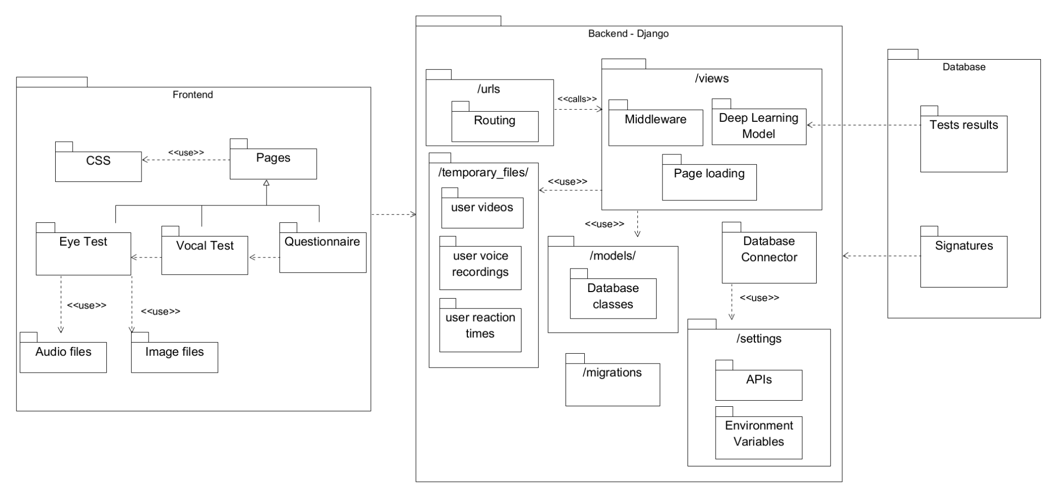We can split the system into 4 core components:

* **Frontend:** Built with HTML, CSS, and JavaScript, the frontend handles user interactions and displays results as well as several static files such as audio files and image files which are used by the various tests we conduct, because we employed Django the HTML pages are saved in the server and rendered when the user sends the corresponding URL route of said page to the back-end, the HTML pages call variables that are sent from the back-end to provide a dynamic front-end experience with the use of Jinja - a python library.
* **Backend:** A Django-based server that processes data, manages user sessions, and interacts with the database and pre-processes the test results before feeding them into the Deep Learning model, this is the central part of the system and this is what we deploy to the cloud - it handles everything from the front-end experience to the Deep Learning model functionality. The back-end houses many folders and files which dictate the system’s functionality and performance and thus we will dedicate an entire section to it later on.
* **Database:** MongoDB is used to store user data, test results, the API key for the database will be found in the environmental variables of the system, alternatively they can be handed over from the original engineering team, the data is saved as documents into one of two collections: **traindata** and **signatures**. The “traindata” documents have 2 attributes:

1. **_id** - which is the default identifier that MongoDB provides.
2. **Label** - which is a long string with the processed test results and the label given by the system, it should be noted that this attributes name changes according to the label given by the system, I.E in one document it can be “No ADHD” and in another it could be “Combined”.

The “signatures” documents have 3 attributes:

1. **_id** - which is the default identifier that MongoDB provides.
2. **full_name** - which is a string with the name provided by the user when they fill out the consent form as well as an underscore (this character _ ) and afterwards the session token of said user’s browser to help us identify them.
3. **signature** - which is a Base64 conversion of a png of the user’s signature provided by the user in the consent form.

* **Deep Learning Model:** A trained model that performs ADHD classification based on the input data, the model is built on top of the tensorflow platform and loads a custom-made/trained set of weights, the file that we load is found in a folder called “/static/weights/” in the back-end, this model was trained on data we extracted by running an experiment on multiple users, said data was saved on our MongoDB instance under the “Nodus” connection, “adhd” database and “traindata” collection.

## 1.2 System Flow

The Nodus system operates through a structured sequence of steps designed to guide the user from initial consent through testing, data collection, and finally to the presentation of results. The following outlines the typical flow of a successful run within the system:

1. **Consent Form Completion:**Upon accessing the system, the user is first presented with an informed consent form. The form outlines the purpose of the study, procedures involved, potential risks, and the user’s rights. To proceed, the user must carefully read the form, input their full name, and provide a digital signature at the end. This ensures that the user has acknowledged and agreed to the terms of participation, this signature is then saved to our MongoDB instance with the help of the function “save_signature_toDB(full_name, signature)”, the full-name is saved as a string and the signature is saved as a binary file.
2. **Instructions Review:**Following the consent form, the user is directed to the instructions page. Here, the system provides detailed guidance on how to perform the tasks that constitute the test. The user is required to read these instructions thoroughly before proceeding to the first test to ensure proper understanding and execution.
3. **Eye-Test Initialization and Calibration:**The first test is the Eye-Test, which begins with a calibration process. The user is asked to focus on a red circle, and a short video recording is made. This video, named "initial-video.webm," is sent to the backend and temporarily stored in the "/temporary_files/" directory. The video is renamed to "{session_key}_initial_video.webm" to ensure it is uniquely identifiable by the session key. The "initial_video_check()" function is then invoked to process this initial video, ensuring the system is calibrated correctly for the user's specific conditions.
4. **Main Eye-Test Execution:**Upon successful calibration, the system signals the user to begin the main Eye-Test. During this test, two key files are generated: "recorded-video.webm," which captures the user's eye movements, and "reaction-time-arrays.txt," which records the user's reaction times. Both files are sent to the backend and saved in the "/temporary_files/" folder under the names "{session_key}_{filename.filetype}," where {filename.filetype} corresponds to the file’s original name and type. These files are handled by the "upload_video()" function, which is responsible for routing them to the appropriate processing workflows.
5. **Vocal-Test Execution:**The next stage involves the Vocal-Test. The user is instructed to read aloud a series of sentences, resulting in the creation of an "audio-recording.mp3" file. This file is sent to the backend, saved to the "/temporary_files/" folder under the name "{session_key}_{filename.filetype}," and immediately processed using the "librosa" Python library. The processing extracts two key variables: "y," representing the audio time series, and "sr," the sample rate of "y." These variables are then used by the "soundfile" library to re-save the file under the same name. This step is critical, as directly saving the initial file may result in a faulty .mp3 format, whereas the re-saved version ensures compatibility for subsequent processing.
6. **Questionnaire Submission:**After completing the Vocal-Test, the user proceeds to the Questionnaire section. The responses are compiled into a file named "questionnaire.txt," where each answer is separated by a comma. This file is sent to the backend and stored in the "/temporary_files/" folder, again under the name "{session_key}_{filename.filetype}," for later processing.
7. **Data Processing and Result Generation:**Upon completion of all tasks, the user is directed to a processing page, during which the backend initiates the "results()" function. This function systematically accesses all the files saved in the "/temporary_files/" directory and begins the analysis and preprocessing of the data using several helper functions. These functions extract and prepare the data, which is then fed into the Deep Learning model via the function "model(eye_analysis, base, dist, voice_analysis, questions)." The model returns an array of floats with a length of four, representing the percentage likelihoods of each ADHD subtype. Finally, the system renders the "test-results.html" page, presenting the user with their results, including the context variables 'percentages,' 'eye_analysis,' 'vocal_analysis,' 'questionnaire,' and 'reaction_time.'

It should be noted that the processed test data can be saved to our MongoDB instance if the user answers “Yes” to the “Save data to train our model?” question at the end of the questionnaire and saving the data happens with the help of the function “save_test_results_toDB(label, data)”, the data is saved as a continuous string with the format: (label : data).

This systematic flow ensures that each step of the process is meticulously handled, from initial data collection to final result presentation, thereby providing an accurate and reliable assessment of the user's ADHD profile.

# 2. Software Dependencies

The Nodus system relies on a specific set of software dependencies to function effectively. This section provides an overview of the key libraries and frameworks used in both the backend and data processing components of the system. Proper management and regular updates of these dependencies are essential to maintaining system stability and performance.

## 2.1 Backend Dependencies

The backend of the Nodus system is built using Django, along with several other libraries that handle data processing, machine learning, and audio/video manipulation. The following are the key dependencies:

* **Python:**Needless to say our project is a python based WEB application, we used python version 3.11.9 - said version was the most compatible with all our libraries.
* **Django:**Django is the primary web framework used to manage the backend of the Nodus system. It handles HTTP requests, manages user sessions, and facilitates interaction with the database. Django’s built-in security features ensure that the system is protected against common web vulnerabilities.
* **OpenCV (cv2):**OpenCV is used for real-time computer vision tasks in the Eye-Test component. It processes video data to detect the user's face, track eye movements, and analyze the video frames, which are crucial for assessing the user's focus and reaction times.
* **Librosa and Parselmouth:**These libraries are employed for audio analysis during the Vocal-Test. Librosa provides tools for extracting features from audio files, such as waveform analysis and spectral representations. Parselmouth, with its Praat integration, enables detailed phonetic analysis of the user’s speech, contributing to the overall assessment.
* **Soundfile (sf):**Soundfile is used to read and write sound files, ensuring that the audio data collected during the Vocal-Test is stored and processed in a format compatible with the system's requirements. It plays a critical role in handling the .mp3 files after they are processed by Librosa.
* **TensorFlow:**TensorFlow is the deep learning framework used in the Nodus system for ADHD classification. The model, built using TensorFlow’s Keras API, processes input data from the tests and generates predictions about ADHD subtypes. TensorFlow’s robust features support the complex computations required for this analysis.
* **MongoEngine:**MongoEngine serves as the interface between Django and MongoDB, allowing seamless interaction with the database. It simplifies data manipulation by providing an Object-Document Mapper (ODM) that integrates with Django’s model system.
* **Other Essential Libraries:**
  + **NumPy (np):** Used for numerical operations, particularly in handling array data.
  + **OS:** Facilitates interaction with the operating system, particularly in file handling.
  + **Pathlib (Path):** Provides an object-oriented interface to interact with the file system.
  + **bson (Binary):** Handles the storage of binary data within MongoDB.

## 2.2 Environment Management

The Nodus system operates within a virtual environment to manage its dependencies. This ensures that all necessary packages are isolated from the system-wide Python installation, preventing conflicts and ensuring consistency across different development and deployment environments.

The project was built on a conda virtual environment as it helps isolate the system from and create a modular safe-to-use version of the system which can be installed on any device.

The environment and all its dependencies can be installed using pip using the “pip install -r requirements.txt” using the requirements.txt file or alternatively can be installed using conda with the “conda env create -f environment.yaml” using the environment.yml file which we provided.

# 3. Code Review

This section of the guide provides a comprehensive analysis of the backend codebase. We will delve into the functionality of each component, explaining the purpose and implementation of the code, as well as its role within the overall system architecture. Additionally, we will discuss best practices for maintaining the code, ensuring its scalability, and facilitating future enhancements. This review aims to equip developers with a deep understanding of the backend’s inner workings, enabling them to effectively manage and extend the system as needed.

## 3.1 manage.py file

This file is responsible for running the server and is provided by default by the Django framework when creating a new project.

To run the server you have to navigate to the folder which has this file and run the following command: “py manage.py runserver”, alternatively you can run the command “python manage.py runserver”.

This file serves no other purpose aside from activating and running the back-end automatically, the default setting of which is the localhost running on port 8000, we won’t be going over the alternatives to running on localhost for we will dedicate an entire section to the deployment.

## 3.2 db_connection.py file

This file is responsible for connecting the back-end to our MongoDB instance, the information needed for said connection are fetched from the operating system’s environmental variables and are labeled “DATABASE_USERNAME” and “DATABASE_PWD” for the username and password respectively.

The connection is then handled by the library PyMongo and can be then accessed by any file in the back-end using the “db” variable declared in this file by using “from db_connection import db”.

## 3.3 FinalProject folder

This is the main folder in our back-end architecture and is provided by default by Django when creating a new project, typically referred to as the "project folder" or "project directory." This folder is crucial as it serves several important functions:

### 3.3.1 settings.py file

This file is a central component of the Django project, responsible for defining the configuration settings that dictate the operational behaviour of the application. This file includes a comprehensive array of settings that govern various aspects of the project, including:

* **Basic Configuration:** The **BASE_DIR** setting establishes the base directory for the project, ensuring that all file paths within the project are correctly resolved relative to this directory.
* **Security Settings:** The **SECRET_KEY** is a critical security measure used for cryptographic signing, essential for securing sessions, cookies, and other sensitive data. In production environments, the DEBUG setting must be disabled (False) to prevent the exposure of sensitive error details. The **ALLOWED_HOSTS** setting specifies which domains are permitted to serve the Django site, protecting against HTTP Host header attacks.
* **Installed Applications:** The **INSTALLED_APPS** section lists all the Django applications that are active within the project. This includes both the built-in Django apps (such as authentication and admin interfaces) and any custom applications developed for the project.
* **Middleware:** Middleware components listed in the **MIDDLEWARE** setting are responsible for processing requests and responses as they pass through the application. Each middleware component performs a specific function, such as managing sessions, enforcing security measures, or transforming HTTP requests and responses. The order of middleware execution is critical to ensure the correct functioning of these components.
* **URL Configuration:** The **ROOT_URLCONF** setting points to the module that contains the URL declarations for the project. This setting is crucial for defining the routing patterns that direct incoming HTTP requests to the appropriate views within the application.
* **Template Configuration:** The **TEMPLATES** setting manages how Django processes and renders templates. It includes settings for the template engine, directories where templates are stored, and context processors that make certain variables globally available to all templates.
* **WSGI Configuration:** The **WSGI_APPLICATION** setting specifies the WSGI application callable that Django uses to serve the project. WSGI (Web Server Gateway Interface) is a standard interface between web servers and Python web applications.
* **Database Configuration:** The **DATABASES** setting defines the database connection details for the project. It specifies the database engine, database name, and other connection parameters necessary for Django to interact with the database.
* **Password Validation:** The **AUTH_PASSWORD_VALIDATORS** setting contains a list of password validation rules that enhance security by enforcing strong, complex passwords. These rules help protect user accounts from unauthorized access.
* **Internationalization and Localization:** The **LANGUAGE_CODE** and **TIME_ZONE** settings control the language and time zone settings for the project. These configurations determine how dates, times, and language-specific content are displayed.
* **Static Files:** The **STATIC_URL** and **STATICFILES_DIRS** settings manage the handling of static files, such as CSS, JavaScript, and images. These settings are essential for serving static content efficiently, both in development and production environments.
* **Default Primary Key Field Type:** The **DEFAULT_AUTO_FIELD** setting defines the type of primary key field that Django will use by default for models. This setting helps streamline database management by ensuring that primary keys are automatically generated and managed.

### 3.3.2 __init__.py file

This file is crucial for the Django framework to function, although it’s an empty file removing it would render the system unusable as it wouldn’t be able to run the server.

### 3.3.3 wsgi.py file

The wsgi.py file is a critical component in the Django project architecture, serving as the entry point for WSGI-compatible web servers to interact with the Django application. WSGI, which stands for Web Server Gateway Interface, is the standard Python interface between web servers and Python web applications. This file is particularly important in production environments, where it facilitates the deployment of the Django project.

The primary function of wsgi.py is to expose the WSGI callable as a module-level variable named application. This variable allows WSGI servers, such as Gunicorn or uWSGI, to communicate with the Django application, handling requests and responses in a standardized way. The wsgi.py file ensures that the application can serve web pages, process data, and perform other web-related tasks efficiently and securely in a production environment.

### 3.3.4 asgi.py file

The asgi.py file plays a similar role to wsgi.py, but it is designed for use with ASGI (Asynchronous Server Gateway Interface) servers. ASGI is a newer standard than WSGI and is designed to handle asynchronous communication, making it more suitable for modern web applications that require real-time features such as WebSockets, chat applications, or live notifications.

The asgi.py file serves as the entry point for ASGI-compatible web servers to interface with the Django application. Like wsgi.py, it exposes an ASGI callable as a module-level variable named application. This allows ASGI servers, such as Daphne or Uvicorn, to manage asynchronous requests and responses, enabling the Django application to handle multiple connections simultaneously without blocking.

ASGI is particularly important for applications that need to manage high levels of concurrency or require long-lived connections, such as streaming data or interactive features. The asgi.py file ensures that the Django project is capable of supporting these advanced functionalities, providing the flexibility to deploy the application in environments that demand asynchronous processing.

### 3.3.5 urls.py file

This file in the FinalProject folder is responsible for routing the urls that arrive at the back-end, if any other routes need be added they could be added to this file or alternatively they could be added to another file and afterwards we can add a route that goes to the new file from this current “urls.py” file.

In our project we chose to do the latter as we primarily worked in a different app folder called ADHD to create an isolated environment, we then added a route using this command: path('', include('ADHD.urls')) - which states that all routes that arrive at this current “urls.py” file should also check the routes in the “urls.py” file in the ADHD app.

## 3.4 ADHD folder

This folder represents the app we created, the Django framework allows developers to create sub apps in the system, each sub app can work independently and are all connected to the central project directory (in our case FinalProject folder).

We decided to create an app called ADHD which has the HTML pages, the JS scripts used in the HTML pages, the server-side logic, the app routes, the database collections, the image, vocal and Deep Learning model weights files and a folder where temporary files are stored as they await processing.

We will go over each file and folder in the ADHD folder and explain their usage in great detail.

### 3.4.1 __pycache__ folder

This folder has compiled versions of the .py files, usually saved with the .pyc file type, this folder basically works as a local version history provided by the Django framework.

**This folder works automatically and should not be changed manually**

### 3.4.2 migrations folder

This folder serves as a version history for the database declared in the settings and the models created in the “models.py” file, the files found in this folder represent changes made to the models found in “models.py” file - thus this folder saves changes made to said models to later merge them with the database instances, allowing for a seamless transition between new and old database.

**This folder works automatically and should not be changed manually**

### 3.4.3 signatures folder

This folder has all the user signatures submitted from the consent form and sent to the back-end, the purpose of this folder is merely to save the signatures locally if the developers choose to work on the localhost instead of the cloud version of the project and need quick access to the signature files as images instead of Binary files.

**This folder is not used by the cloud version and will not see any changes on its own, it exists purely for testing and verification purposes.**

### 3.4.4 static folder

This folder has all the non-HTML static files, I.E images, audio files and Deep Learning model weights, the files in the static folder are organized into 4 main categories: Images, Audio, Scripts and Weights - all of which are subfolders that have several files, it should be mentioned that the scripts folder is not in use anymore as each HTML page has it’s own scripts embedded in the page.

Any change/additional functionality to any of the HTML scripts should be resolved in the HTML page itself, as inserting new scripts into this folder will not trigger them as we ran into several issues with Django static file calling the script and having 2 way communication between the script files and the HTML scripts.

The Deep Learning model weights should be put in the “weights” subfolder in the “static” folder under the same name as the old weights file in order for the model to load the weights successfully, alternatively once can change the name of the weights file loaded into the model, the code can be found directly under the imports in the “views.py” file.

### 3.4.5 templates folder

This folder has all the HTML pages, we preferred putting the HTML pages in a separate file and not in the static folder.

This folder is used when the back-end renders an HTML page.

### 3.4.6 temporary_files folder

This folder serves as a local storage in the back-end, all the user test result files are stored in this folder temporarily until the pre-processing part is done and the model does its calculations and gives the final results.

The contents of this folder change constantly all on their own, a user’s files are saved with his session_key in their name to help us clean the appropriate files when the tests conclude and the results are shown.

### 3.4.7 __init__.py file

Just as we mentioned before, this file is crucial for the Django framework to function, although it’s an empty file, removing it would render the system unusable as it wouldn’t be able to run the server.

### 3.4.8 admin.py file

This file in the Django app directory is responsible for registering models to the Django admin interface. This file allows the models defined in the app to be managed through Django's built-in admin panel (a WEB page). To make a model accessible in the admin interface, it must be imported and registered within admin.py using admin.site.register(ModelName).

In our project, we did not use the admin.py functionality, we didn’t find it necessary for our system’s development.

### 3.4.9 apps.py file

The apps.py file in the ADHD app is used to configure the app's settings within the Django project. It defines the AdhdConfig class, which inherits from AppConfig. This class specifies the configuration for the ADHD app, including the default type of primary key field used for models (BigAutoField) and the name of the app ('ADHD'). This configuration is automatically referenced by Django when the app is included in the INSTALLED_APPS setting of the project's settings.py file.

### 3.4.10 models.py file

The models.py file in the ADHD app is responsible for defining the data models used within the application. In Django, models are the source of truth for the structure of your database tables. This file contains an unused model which is the Patient model. which defines the schema for storing patient data, including fields like Subtype and Percentage, both of which are character fields with a maximum length of 255 characters - said model can be removed, it is not necessary for the system’s functionality.

Additionally, this file sets up connections to MongoDB collections using the db_connection module. The signatures_collection and train_data_collection variables represent the MongoDB collections named 'signatures' and 'traindata', respectively. These collections are accessed directly in the application for storing and retrieving patient-related data outside of Django's ORM.

### 3.4.11 tests.py file

The tests.py file in the ADHD app is typically used for writing automated tests to validate the functionality of the application. It is provided by Django as a default location for unit tests using Django's TestCase class. However, in our project, this file was not utilized, and no tests were implemented within it. If testing is required in the future, this file can be used to create and organize test cases to ensure the reliability and correctness of the app’s functionality.

### 3.4.12 urls.py file

This file in the ADHD app is responsible for defining the URL routing patterns for the application. It maps URL paths to specific views, determining how incoming requests are handled and which part of the application responds. This file includes routes for all major components of the system, such as the eye test, vocal test, questionnaire, and results page. Each URL pattern is associated with a corresponding view function in the views.py file, allowing for organized and efficient handling of user requests.

Key routes include:

* **ADHD**: Routes to the eye test page.
* **Landing/Home**: Routes to the landing page of the application.
* **FAQ**: Routes to the Frequently Asked Questions page.
* **Instructions**: Routes to the instructions page before tests begin.
* **Video Configuration**: Handles video upload and processing for the eye test.
* **Vocal Test**: Routes to the vocal test page.
* **Questionnaire**: Routes to the questionnaire page.
* **Audio Configuration**: Handles audio upload and processing for the vocal test.
* **Results**: Displays the test results.
* **Processing**: Indicates that the results are being processed.
* **Done**: Cleans up and finalizes the session.
* **Consent**: Routes to the consent form.
* **Signature**: Handles the saving of user signatures.

This file is central to the operation of the ADHD app, ensuring that all user interactions are correctly routed to the appropriate functionality within the application.

### 3.4.13 views.py file

This file has all the main functionality of the back-end, it’s made up of various functions which are connected to the routes as well as the declaration and usage functionality of the Deep Learning model.

We will dedicate the next section to this file specifically as most of the work was done in it.

# 4. Back-end Code

This section serves as the expanded and practical review of the “views.py” file specifically, in this section we will explain each function making up the file, including their purpose, their method of achieving said purpose, inputs and outputs.

## 4.1 Deep Learning model

The declaration starts straight after the imports (line 25), its a multi-layered model which receives the a NumPy array which represents the various inputs:

“” **eye_tracking_input_shape = (3,)** “”

“” **reaction_time_input_shape_1 = (3,)** “”

“” **reaction_time_input_shape_2 = (3,)** “”

“” **audio_input_shape = (5,)** “”

“” **questionnaire_input_shape = (20,)** “”

In total the model receives 34 numbers as inputs, it processes the inputs in a concatenated fashion, we see the concatenation in the following line:

“” **concatenated = Concatenate()([x_eye, x_reaction_time_1, x_reaction_time_2, x_audio, x_questionnaire])** “”

The model then loads the weights found in the static folder, see the following lines:

“” **weight_path = Path('ADHD/static/weights/modelweights.weights.h5)** “”

“” **model_pred.load_weights(weight_path)** “”

The model is also used the following function:

“” **def model(eye, react1, react2, vocal, questions)** “”

Which receives the input arrays as strings and turns them to NumPy arrays in the shape mentioned above and feeds that data to the model, which then returns a NumPy array of floats in the shape (4,) which represent percentages summing up to 1.

## 4.2 Render Functions

We will now go over all the functions that merely render an HTML page.

Said functions include:

* **def consentForm(request)**
* **def instructions(request)**
* **def eyeTest(request)**
* **def vocalTest(request)**
* **def questionnaire(request)**
* **def landingPage(request)**
* **def FAQ(request)**
* **def processing(request)**

All the functions mentioned above render their HTML respectively and do nothing more, they receive a Django request as input and return the rendered HTML page.

We see the following lines of code that render pages at the end of each one of said functions:

“” **template = loader.get_template('{HTML_PAGE}')** “”

“” **return HttpResponse(template.render())** “”

Aside from that each one of those functions has access to the session_key variable which is an identifier found in the user request, the functions save that session_key to a local variable should they need it.

## 4.3 Data Processing Functions

This section will handle the functions which process data, both the ones that pre-process them before feeding them to the back-end and the ones that deal with the data when it first arrives at the back-end.

We will list the functions based on the order in which they appear in the “views.py” file:

* **def saveSignature(request)** - receives the user’s signature and full-name and saves the signature as a Binary file into the MongoDB instance. This function is labeled with csrf_exempt because it saves a file locally in the back-end.
* **def clean(request)** - receives a request from a user, extracts the session_key of the user and removes all the user’s files saved locally in the back-end.
* **def results(request)** - receives a request from a user, extracts the session_key and loads all the files saved in the back-end of said user based on the session_key, processes them using other helper functions and concatenates all the results to 1 string and splits that string into multiple tuples and send those tuples to the “model” function - the “results” function returns a rendered “test-results.html” page with the ADHD subtype percentages along with tips for how to deal with the most prominent subtype.
* **def upload_video(request)** - receives a request from a user with a video in the .webm format, this function saves that video locally in the /temporary_files/ folder under the name {session_key}_{video_name}. If the video received is the first video or “initial_video.webm” this function then calls the next function and returns its result to the user.
* **def initial_video_check(url)** - This function receives the file path of a video as input and processes it to determine whether the user’s face and eyes are detected consistently throughout the video. The function uses OpenCV’s pre-trained Haar cascades for face and eye detection. It reads the video frame by frame, counting the number of frames where faces and eyes are successfully detected. After processing all frames, it returns a boolean value based on whether the number of frames with successful detections is significantly greater than those without. Specifically, the function returns True if the number of detected frames is more than 1.5 times the undetected frames and there are more than 40 detected frames in total.
* **def eye_test_analysis(url)** - This function processes a video file to track and analyze the user’s eye movements during an eye-tracking test, utilizing OpenCV’s Haar cascades for face and eye detection. As the video is read frame by frame, the function identifies the user's face and then detects the eyes within the region of interest. It records the initial coordinates of the left and right eyes and tracks their movements throughout the video, storing these movements in arrays. The function then calculates the differences in eye positions over time and computes the mean, median, and standard deviation of these movements for both eyes. The results are returned as a summary of the user's eye-tracking data, which can be used to assess their focus and reaction during the test.
* **def upload_voice(request)** - This function handles the upload and processing of an audio file submitted by the user. It begins by ensuring that the user has an active session, creating one if necessary, and retrieves the session key to uniquely identify the file. When a POST request containing an audio file (specifically named 'audio-recording') is received, the function saves the file locally in the /ADHD/temporary_files/ directory, appending the session key to the file name for identification. The audio file is then processed using the librosa library to load the audio data, after which it is re-saved using the soundfile library (sf.write) to ensure the file is in a compatible format for further processing.
* **def analyze_voice(url)** - This function processes an audio file from the vocal test to analyze various vocal characteristics of the user. The function begins by extracting the Fundamental Frequency (F0) of the audio, which is a key measure of pitch. It then calculates additional vocal metrics such as jitter, shimmer, and Harmonics-to-Noise Ratio (HNR), which provide insights into the stability and quality of the user's voice. Finally, the function computes a composite metric called the Voice Quality Index (VQI), which combines these individual metrics into a single value that offers a general assessment of vocal quality. The function returns these five values—F0, jitter, shimmer, HNR, and VQI—which can be used for further analysis or evaluation of the user's vocal characteristics.
* **def upload_answers(request)** - This function handles the upload and saving of the user's responses to the questionnaire. It begins by ensuring the user has an active session, creating one if necessary, and retrieves the session key to uniquely identify the file. When a POST request containing the questionnaire answers is received, the function saves these answers locally in the /ADHD/temporary_files/ directory, naming the file with the session key followed by the filename to ensure it is uniquely associated with the user's session.

It should also be mentioned that some of these functions employ a progression system, this is what the progression system looks like in the code:

“” **if request.session.get('progress') != 'step3':** “”

“” **return redirect('/ADHD/')** “”

## 

## 4.4 Helper Functions

This section will handle the helper functions, which are functions with generic functionality which are reused throughout the code, many of the functions in the last section rely on the functions covered in this section.

We will list the functions based on the order in which they appear in the “views.py” file:

* **def getLabel(questionnaire)** - This helper function determines the user's ADHD subtype based on their responses to the questionnaire. The function initializes two counters, inat and hyp, to track symptoms related to inattention and hyperactivity, respectively. It then iterates through the user's answers, converting each answer from a string to an integer. For the first 9 questions, responses of 2 or 3 increase the inat counter, indicating inattention symptoms. For the next 9 questions, similar responses increase the hyp counter, indicating hyperactivity symptoms. After evaluating the relevant answers, the function categorizes the user into one of four subtypes: "Combined" (if both inattention and hyperactivity symptoms are prominent), "Hyperactivity" (if only hyperactivity symptoms are prominent), "Inattentive" (if only inattention symptoms are prominent), or "No ADHD" (if neither set of symptoms is sufficiently present). This categorization is returned as the function's output.
* **def get_tips(percentages)** - This helper function provides tailored tips based on the user's ADHD subtype, determined by the highest percentage value in the input array. The function defines four different sets of tips corresponding to the possible subtypes: "Combined," "Hyperactive," "Inattentive," and "No ADHD." Each set of tips offers specific advice to help manage symptoms associated with that subtype or to promote overall well-being. The function stores these tips in an array and uses np.argmax(percentages) to identify the index of the highest percentage, which corresponds to the user's most likely subtype. The function then returns the set of tips associated with that subtype, providing personalized guidance to the user based on their individual needs.
* **def calculate_difference(eye_position_array)** - This helper function calculates the squared differences between consecutive eye positions in the provided array. The function iterates through the eye_position_array, which contains the coordinates of the eye positions at each step of the eye-tracking test. For each pair of consecutive positions, it computes the squared distance using the distance_squared function and appends this value to a new list called difference. The function returns this list of squared differences, which can be used to analyze the variability and movement of the user's eyes over time.
* **def distance_squared(point1, point2)** - This helper function calculates the squared Euclidean distance between two points, point1 and point2, in a 2D space. Each point is represented as a pair of coordinates (x, y). The function computes the difference between the x-coordinates and the y-coordinates of the two points, squares these differences, and then sums them to produce the squared distance. The result is returned as a single numerical value, which is used to measure the distance between the two points without taking the square root, thereby avoiding unnecessary computation in contexts where the squared distance is sufficient.
* **def calculate_mean_median_std(eye_movement_distance_array)** - This helper function computes three statistical measures—mean, median, and standard deviation—for a given array or list of numerical values, specifically distances related to eye movements. The function begins by iterating through the input eye_movement_distance_array and appending each value to a new list called data. It then uses NumPy functions to calculate the mean, median, and standard deviation of the values in data. These three statistical measures are returned as a tuple, providing a summary of the distribution and variability of the eye movement distances.
* **def extract_fundamental_frequency(audio_path)** - This helper function extracts the Fundamental Frequency (F0) from the user's voice, which is a key measure of pitch. The function uses the parselmouth library to process the audio file specified by audio_path. It first creates a Sound object from the audio file and then generates a pitch object using the To Pitch function, specifying a range of expected pitch frequencies (from 75 to 600 Hz). The function then calculates the mean fundamental frequency across the entire audio file in Hertz using the Get mean function. The calculated mean F0 is returned as a numerical value, representing the average pitch of the user's voice.
* **def extract_jitter_shimmer_hnr(audio_path)** - This helper function analyzes the user's voice to extract three important vocal characteristics: Jitter, Shimmer, and Harmonics-to-Noise Ratio (HNR). Using the parselmouth library, the function processes the audio file provided through audio_path, first creating a Sound object and generating a PointProcess object to analyze the periodicity of the voice within a typical pitch range. It calculates Jitter, which measures frequency variation and reflects pitch stability, Shimmer, which measures amplitude variation and indicates the consistency of voice amplitude, and HNR, which assesses the ratio of harmonic sounds to noise, indicating vocal clarity. These metrics are then returned as a tuple, providing a comprehensive analysis of the user's vocal quality.

## 4.5 Database Functions

This is a short section, it delves into the functions in the “views.py” file that have access to the MongoDB instance.

There are only 3 functions that access the database, 1 of which is not used at the moment but it exists to help us extract information from the database by using the back-end instead of MongoDB Compass or Atlas.

We will list the functions based on the order in which they appear in the “views.py” file:

* **def save_signature_toDB(full_name, signature)** - This function saves a user's digital signature to a MongoDB database. It first checks if the provided signature is an instance of InMemoryUploadedFile, ensuring that the uploaded file is valid. If valid, the function reads the file content and converts it into BSON Binary format, which is suitable for storing in MongoDB. It then creates a record containing the user's full name and the binary signature, which is inserted into the signatures_collection in MongoDB. The function returns an HTTP response indicating the successful addition of a new record. If the file type is invalid, it returns an HTTP response with a status of 400, indicating the error.
* **def save_test_results_toDB(label, data)** - This function is designed to create a record for storing test results in a database. It takes two parameters: label, which identifies the type or category of data being stored, and data, which contains the actual test results. The function creates a dictionary where the label serves as the key and data as the corresponding value, effectively organizing the test results under the specified label. However, the function as written does not currently save the record to a database or return any response, so additional implementation is needed to complete the storage process.
* **def get_all_signatures(request)** - This function retrieves all digital signatures stored in the MongoDB signatures_collection. It queries the collection using the find() method, which returns a cursor containing all documents (signatures) in the collection. The function then returns this cursor, which can be used to iterate over and access the individual signature records. Currently, the function does not format or process the results for display, nor does it return an HTTP response, so further implementation may be needed depending on how the data will be used or presented.

# 5. Deployment

## 5.1 Overview

Our service was deployed on the Render platform. The platform’s environment is simple and easy to use, with minimal configuration required. The deployment is directly linked to the [GitHub repository](https://github.com/Safwan-Halabi/Backend/tree/main)’s main branch where the project resides. This integration allows for a streamlined update process: whenever new commits are pushed to the repository, Render automatically detects these changes and triggers a redeployment. This continuous deployment pipeline ensures that the website stays up-to-date with the latest code, reducing manual intervention. Render integrates a linux shell, allowing an easy way to access the cloned files from the github which the deployment is built upon, as well as modifying them, however, the modification is only done in the render environment and does not affect the github repository.

## 5.2 Render dashboard

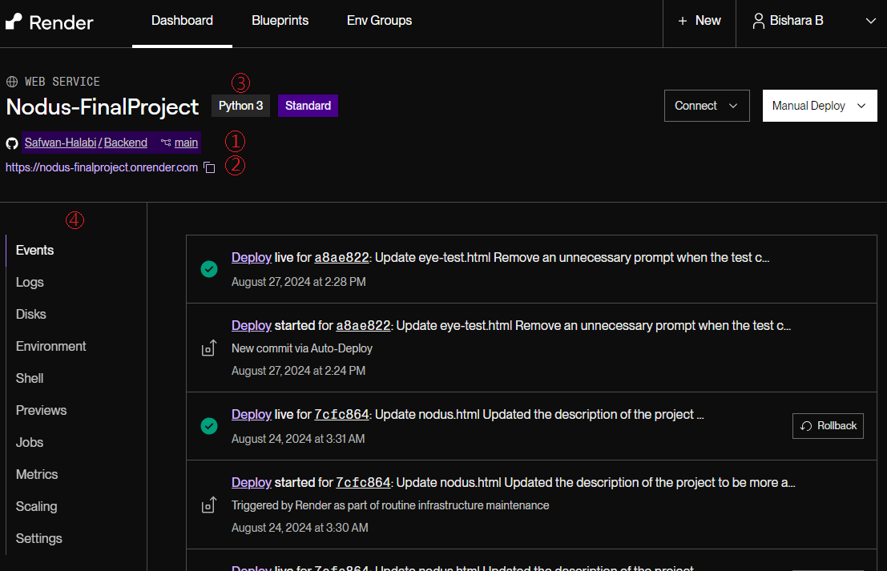

The above image represents the Render dashboard. Key components in the page:

1. The main repository of the *Backend* github repository.
2. The website’s URL provided by Render.
3. Python3: Our project was developed with 3.11.9.
4. The control panel for configuring the deployed service.

## 5.3 The control panel

The control panel (Denoted (4) in the image from the previous section: Render’s dashboard) is the main tool for configuring the website. Includes: Events, Logs, Disks, Environment, Shell, Previews, Jobs, Metrics, Scaling and Settings. However not all of the said tools are necessary to use and modify. The next subsections will discuss the applications of the tools we have used to maintain our web service.

### 5.3.1 Events

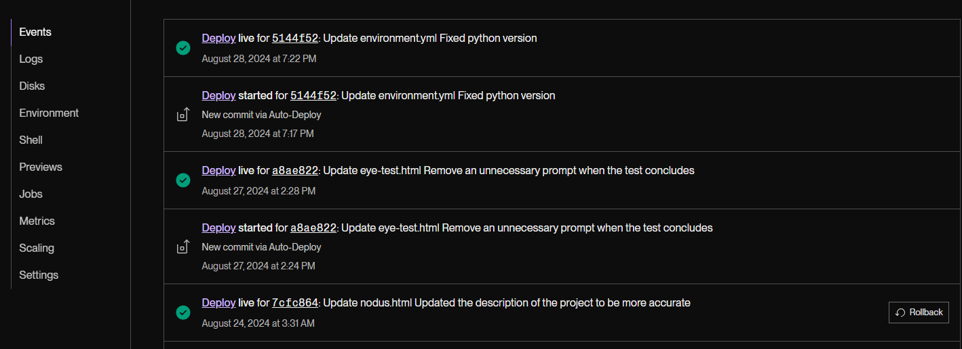

**Events** section provides a summary of entries representing the previously deployed commits to the Github repository, Each entry can be accessed, displaying a detailed log on the deployment process. Example log will be presented in the next subsection

### 5.3.2 Logs

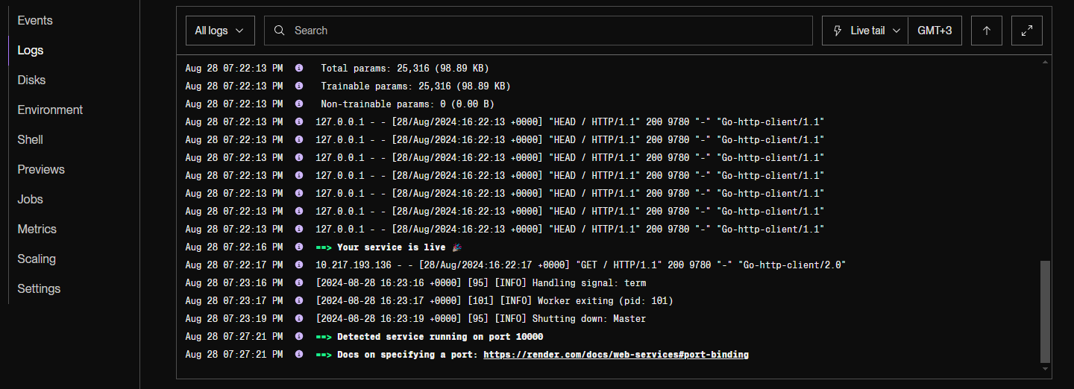

**Logs** section displays the log that corresponds to the current deployed version of the service, providing a detailed look into the website’s deployment status, and visitors’ activities on the website. In the above image, a message saying: “Your service is live” conveying that the service has been successfully deployed and live. It also displays the “GET” and “POST” requests.

### 5.3.3 Environment

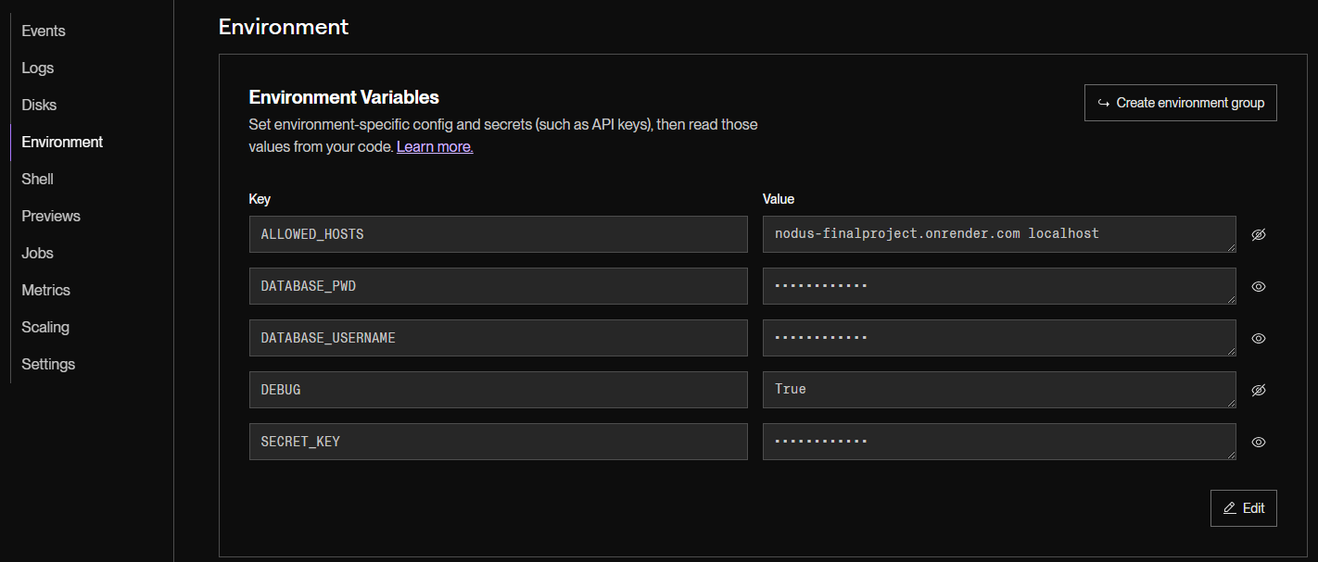

The **Environment** section stores the environment variables used for this project. These variables include sensitive information and configuration settings such as database credentials, API keys, and debug modes, which are essential for the application to run correctly in different environments (e.g., development, testing, production).

By storing these variables in Render, they are securely encrypted and kept separate from the codebase, reducing the risk of accidental exposure. Moreover, the environment variables can be easily updated without requiring changes to the code, allowing for flexible configuration and quicker deployment adjustments as needed.

The following is the goal of each key:

* **ALLOWED_HOSTS**: Specifies a list of host/domain names that the web server can serve. This prevents HTTP Host header attacks. In this case, it allows requests from the website’s URL and localhost.
* **DATABASE_PWD**: Stores the password for accessing the project's database.
* **DATABASE_USERNAME**: Contains the username used to connect to the project's database.
* **DEBUG**: A boolean setting (True or False) that determines whether the deployment is in debug mode. When set to True, detailed error pages will be shown; for production, this should be set to False.
* **SECRET_KEY**: A unique key used for cryptographic signing, such as sessions and cookies in web applications. The key is generated by Render.

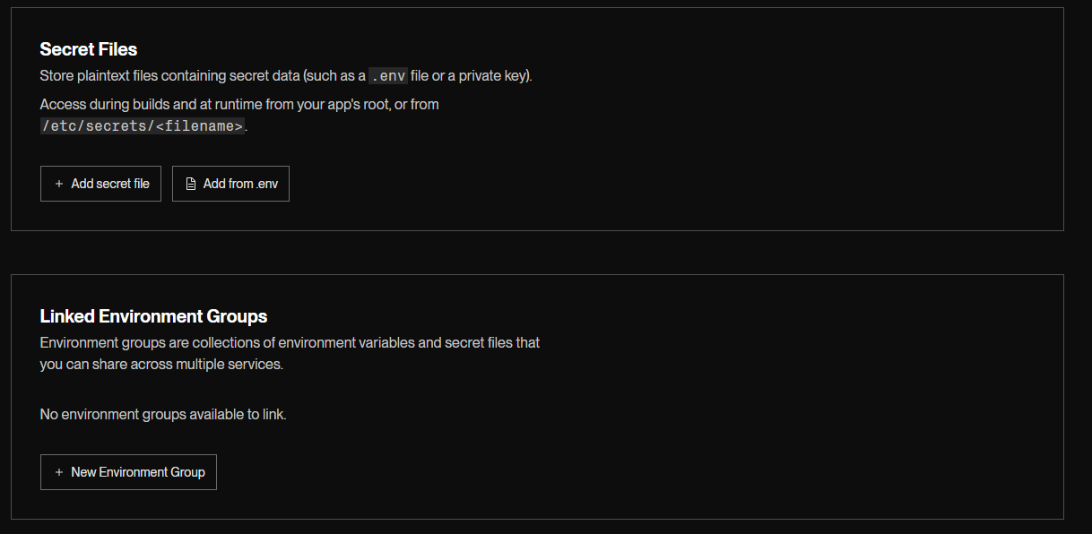

Environment section enables storing Secret Files, and Linked Environment Groups. The said settings are not used for this project.

### 5.3.4 Shell

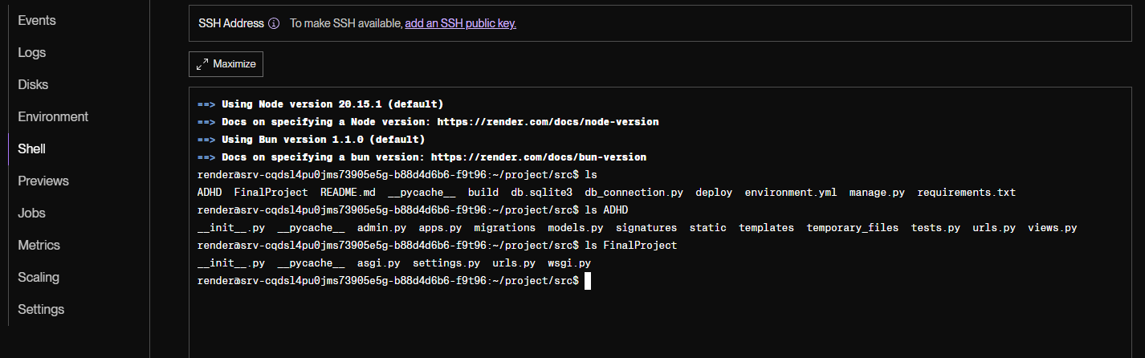

The **Shell** section in Render provides a linux command-line interface (CLI) to the server environment where the project is hosted. This feature allows developers to execute commands directly on the server, making it easier to perform various administrative tasks such as inspecting files, managing processes, running scripts, and debugging.

In the screenshot, the shell output shows commands like *ls*, which lists the contents of the project's directory which has been cloned and deployed.

The Shell tool is particularly useful for quickly accessing the server to make adjustments or monitor the deployment's health, providing flexibility and control over the deployed application.

### 5.3.5 Metrics

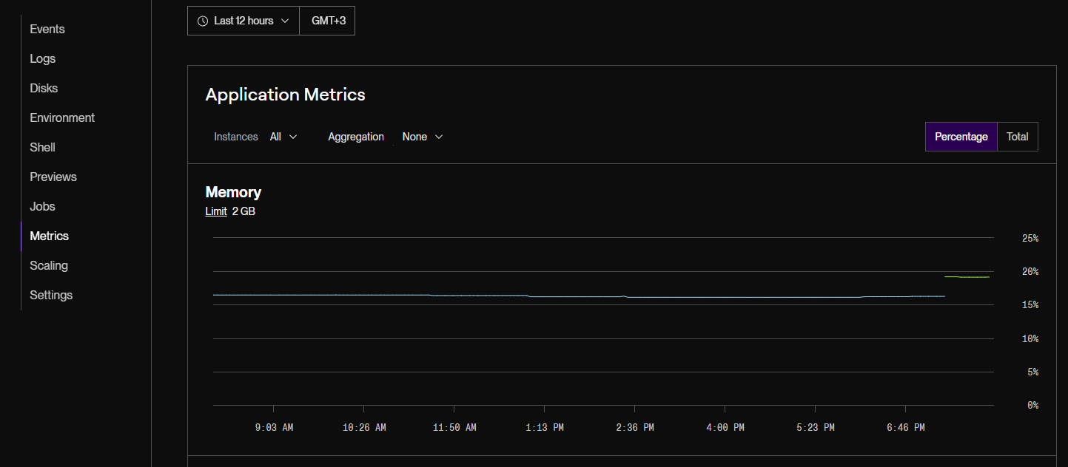

The **Metrics** section provides valuable insights into the application's performance, and resource usage, allowing for proactive management and optimization.

The screenshot shows the **Memory** usage graph, which displays the amount of memory being used by the application over time. The memory limit is set to 2 GB, and the graph shows the memory consumption in percentage or total usage.

Other metrics available in this section (though not shown in the screenshot) include: CPU Usage, Network metrics including total requests and response times, and Outbound bandwidth.

### 5.3.6 Settings

**General section:**

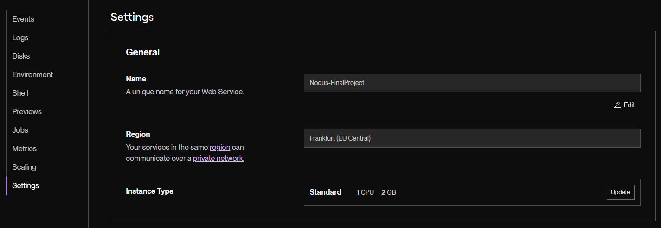

The **Settings** section is the main configuration point of the entire deployment. We will go over all the settings presented in the section. In the image above, General settings show the Name, Region and Instance type of the deployment. Currently, the instance type is set to standard, which can be upgraded to higher tiers, offering better resources for the website to run (higher CPU and RAM).

**Build & Deploy section:**

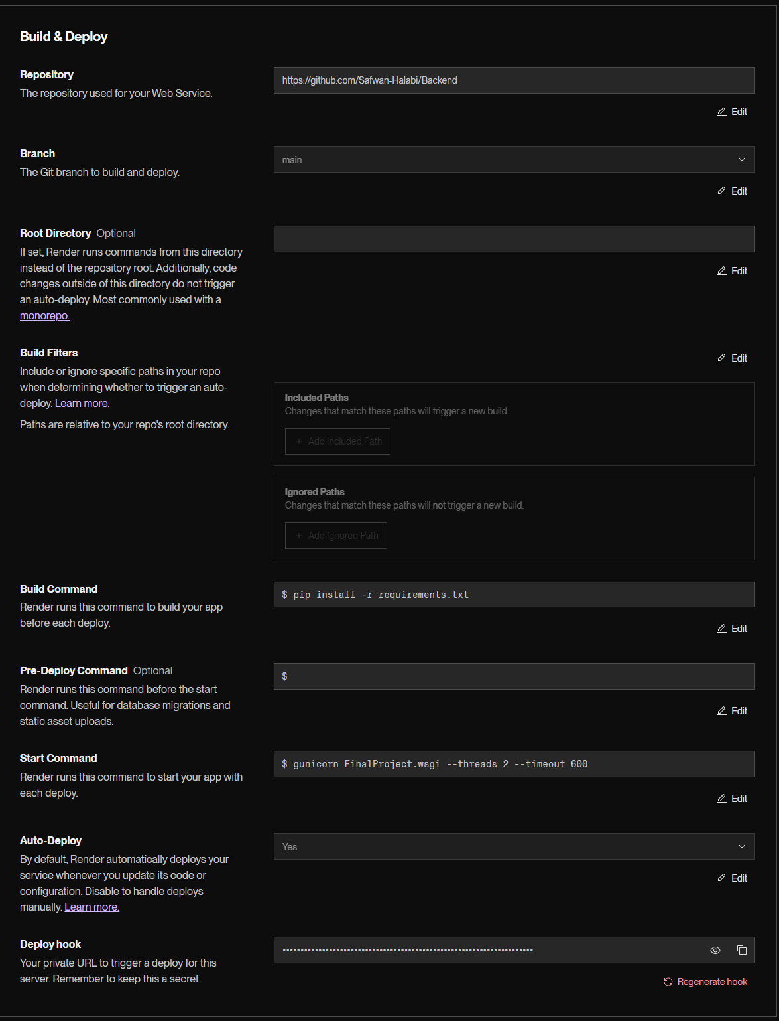

For the **Build & Deploy** section, the important parts are:

* **Repository:** The Github repository that contains the project
* **Branch:** The branch that will be used to deploy the project.
* **Root Directory:** Specifies the path to the source files of the entire project. For this project, it is not needed to specify, as the source files are placed at the base level of the directory.
* **Build command:** Command that runs before deploying the project. It is necessary to install the required libraries. In this project, libraries are detailed in the requirements.txt file.
* **Start Command:** The project uses *gunicorn* library, it’s best to run the command: “gunicorn FinalProject.wsgi --threads 2 --timeout 600”
* **Auto-Deploy:** Specifies whether to deploy the project automatically upon pushing changes to the branch used to deploy the project. Default set to Yes

For **Custom Domains**, **PR Previews**, **Notifications** and **Health Checks**, no changes have been made.

# External Links and Documentation

For further documentation and more information about the following subjects, visit the links provided below:

* The Django Framework - [Django Documentation](https://docs.djangoproject.com/en/5.1/)
* Python - [Python Documentation](https://docs.python.org/3.11/)
* OpenCV - [OpenCV Documentation](https://docs.opencv.org/4.x/index.html)
* Librosa - [Librosa Documentation](https://librosa.org/doc/latest/index.html)
* Parselmouth - [Parselmouth Documentation](https://parselmouth.readthedocs.io/en/stable/)
* Soundfile - [Soundfile Documentation](https://python-soundfile.readthedocs.io/en/0.11.0/)
* TensorFlow - [TensorFlow Documentation](https://www.tensorflow.org/api_docs)
* MongoEngine - [PyMongo Documentation](https://pymongo.readthedocs.io/en/stable/)